

**User GUIDE**Version 4.0

Isabelle LECOMTE

18th September 2018

# Hi-sAFe overview

Hi-sAFe is a dynamic generic model simulating interactions between plants (trees and crops) in three dimensions, which account for the classical balance of materials and energy (water, nitrogen, light).

Hi-sAFe is implemented under the **CAPSIS** modelling platform (De Coligny et al, 2002) which is portable software, freely available under a GNU license (<http://capsis.cirad.fr/capsis/home>). The Capsis project aims at integrating several types of forest growth and dynamic models and providing forest management tools to establish and compare different silviculture scenarios.

Hi-sAFe is designed to simulate scenes such as:

* Mixtures of trees and crops, whether trees are aligned, dispersed or isolated
* Perennial row crops with ground cover
* Mixtures of herbaceous crops, foot, row or strip
* Multi-species forests
* Isolated trees (urban trees, hedges) with or without ground vegetation
* Plots of pure crops with spatial heterogeneity
* Precision agriculture (technical itineraries adapted to the spatial heterogeneity of the stand)

A tree model has been specifically developed with 6 main modules:

* Phenology
* Light interception
* Water demand calculation
* C allocation
* Fine root growth
* Coarse root topology growth

STICS(Brisson et al, 2001) is the crop model embedded in Hi-sAFe. It has been in development at INRA-Avignon (France) since 1996 (<http://www6.paca.inra.fr/stics>). STICS simulates crop growth as well as soil water and nitrogen balances driven by daily climatic data. It calculates both agricultural variables (yield, input consumption) and environmental variables (water and nitrogen losses). One of the key elements of STICS is its adaptability to various crops. This is achieved by the use of generic parameters relevant for most crops and with options in the model concepts concerning both physiology and management, which have to be chosen for each crop.

The water and nitrogen repartition module between trees and crop also has been specially designed for HisAFe with a **minimisation of energy approach**. This simply means that the resources will be extracted where it is the easiest (plants are lazy). The model should be able to describe the opportunism of plants in heterogeneous environments, and especially when heterogeneity results from plant competition.

# Hi-sAFe simulated scene

Usual agroforestry projects will take place at a variety of scales, but the Hi-sAFe belowground modules must operate at relatively small horizontal and vertical scales, over which local conditions can vary significantly. The following diagrams describe the process by which we move from the field scale through to the soil scale at which the Hi-sAFe belowground modules will operate.



Figure 1: Spatial resolution – from the field scale to the voxel scale

The Hi-sAFe soil resolution is not only based on structural characteristics (pedologic layers) but also on a *maximum* thickness of soil suitable for the water extraction and the cellular automata module (for tree root growth) being simultaneously developed. The decision was reached to call these intermediate sub-layers “*voxels”*. The term is a contraction of “volume element” (by analogy with ‘pixel’), and is commonly used in three-dimensional modelling. A voxel is defined as ‘”*the smallest distinguishable box-shaped part of a three-dimensional space*”. The voxels will differ in terms of their water content, even if they share similar soil structural parameters. Further discussions centred on whether to consider only voxels of uniform dimensions (*e.g.* 1m X 1m X 1m), or whether it was necessary to be able to have non-cubic voxels. Eventually it was decided that the horizontal X-Y dimensions of voxels in Hi-sAFe would be uniform (*i.e.* square), but that the depth (Z-dimension) could vary. This was necessary in order to be able to divide the compartments (of variable depth due to the heterogeneity of the soil pedological layers) into discrete voxels.

**CAPSIS cell:**

Considered for modelling purposes as the

cell into which the plot is divided and the soil

column lying beneath it

**Layers**

**:**

Defined as t

he intersection between the CAPSIS

cell (column) and one of the soil pedological layers

(shown here in different colours

)

**Voxel:**

Compartments consist of one or more

*voxels*

,

each of which will have the same soil properties.

Voxels have a maximum allowed dep

th

Figure 2: Definition of terms used in modules describing soil processes

Hi-sAFe includes toric symmetry algorithms that avoid generating artificial edge effects for heterogeneous stands (the scene is surrounded virtually by identical scenes)

Hi-sAFe can be used on simple scenes (for example centered on an average tree) or on complex scenes (eg including many trees with varying developments).

# Running Hi-sAFe

Hi-sAFe installation creates a **capsis_install_folder\capsis4\data\safe** folder on your computer containing:

* cropInterventions: containing 23 crop intervention input files (*.itk)
* cropSpecies: containing 23 crops species parameters files (*.plt)
* exportParameters: containing 10 export profiles (*.pro)
* generalParameters: containing STICS and Hi-sAFe general parameters file (*.par)
* plotDescription: containing 10 example of plot description input file (*.pld)
* simSettings: containing 1 batch simulation folder example
* treeSpecies: containing 3 tree species parameters files (*.tree)
* weather: containing 1 weather input file (*.wth)

**Each time you re-install or upgrade Hi-sAFe, this folder will be erased!**

**Copy this folder another part of your disk, and use this new folder to store your own simulation data.**

## Grafical User Interface (GUI) mode

GUI mode is convenient to check plot configuration and run small simulations (1 or 2 years), but most of the time, BATCH mode is much more appropriate for multi-years simulations.

To run Hi-sAFe GUI, click on the Capsis desktop shortcut or open a DOS prompt and execute

c:\my_capsis_folder\capsis4 > capsis (in French)

c:\my_capsis_folder\capsis4 > capsis –l en (in English)

A DOS window and Capsis GUI will open simultaneously.

|  |  |
| --- | --- |
|  |  |

Choose “Create a new project” and click on **OK**

Give a name to the project, choose **Hi-sAFe** model and click on **Initialise**

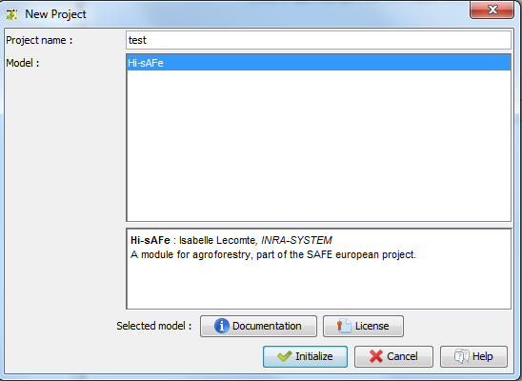

Initialise the project by giving a plot description file name. This file will contain all usefull information for designing the virtual scene (dimension, soil description and planted trees species). All details about the plot description file are in chapter 4.1.

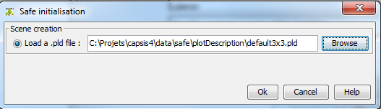

Click on the **Browse** buttonto choose a file on your computer, then **OK**

Click on the root step (**0/0/0a**) and then on **HiSAFE viewer** (on the left part of the screen)

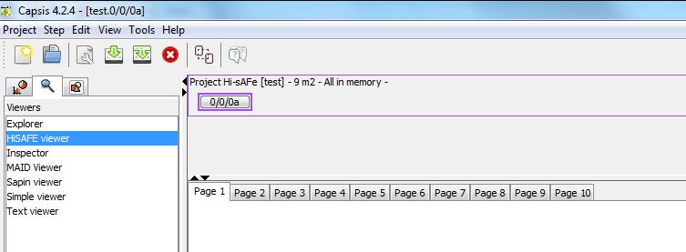

You can check the plot design

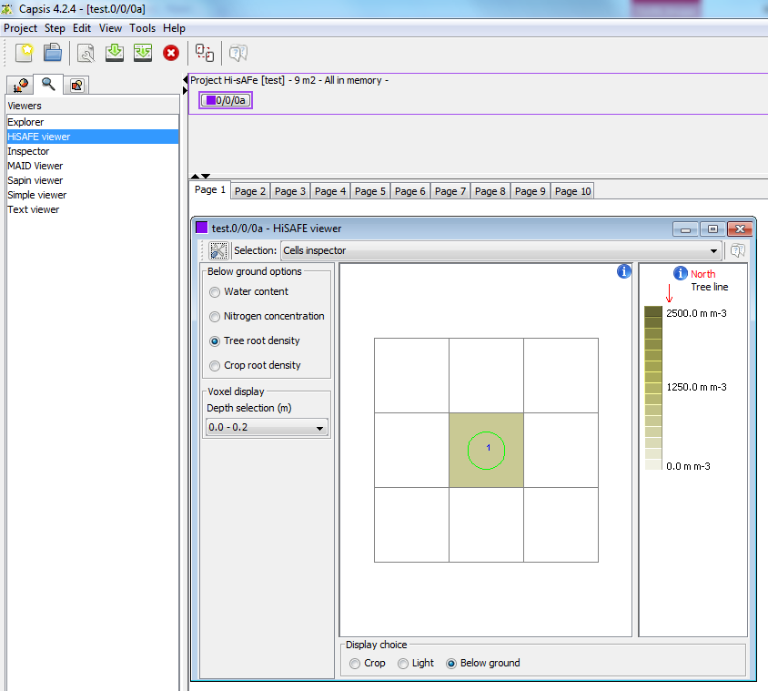

Before running the simulation, it is possible to change the memory option to reduce the step that will be memorised in the CAPSIS project. Right-click on root step and choose “C**onfigure**”

|  |  |
| --- | --- |
|  |  |

**Memory options:**

* All in memory : all steps are stored
* Compact : only the last step is stored
* Frequency : Only some steps are stored depending on the frequency defined

To run a Hi-sAFe simulation: right click on the root step (**0/0/0a**) of the project to choose “**Evolution**”

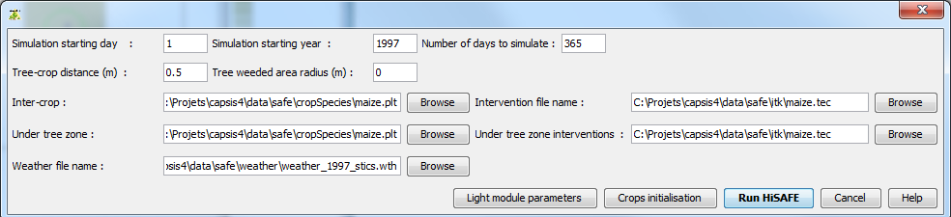

Fill in all simulation information:

* Simulation starting date (in DOY)
* Simulation starting year
* Number of days for the simulation (1-365 max)
* Inter-crop species name and intenvention file
* Under tree zone species name and intenvention file
* Weather file name

Then click on “**Run Hi-sAFe**”



The progress bar at the bottom of the screen shows the evolution of the simulation.

When the simulation is complete the last step appears next the root step.

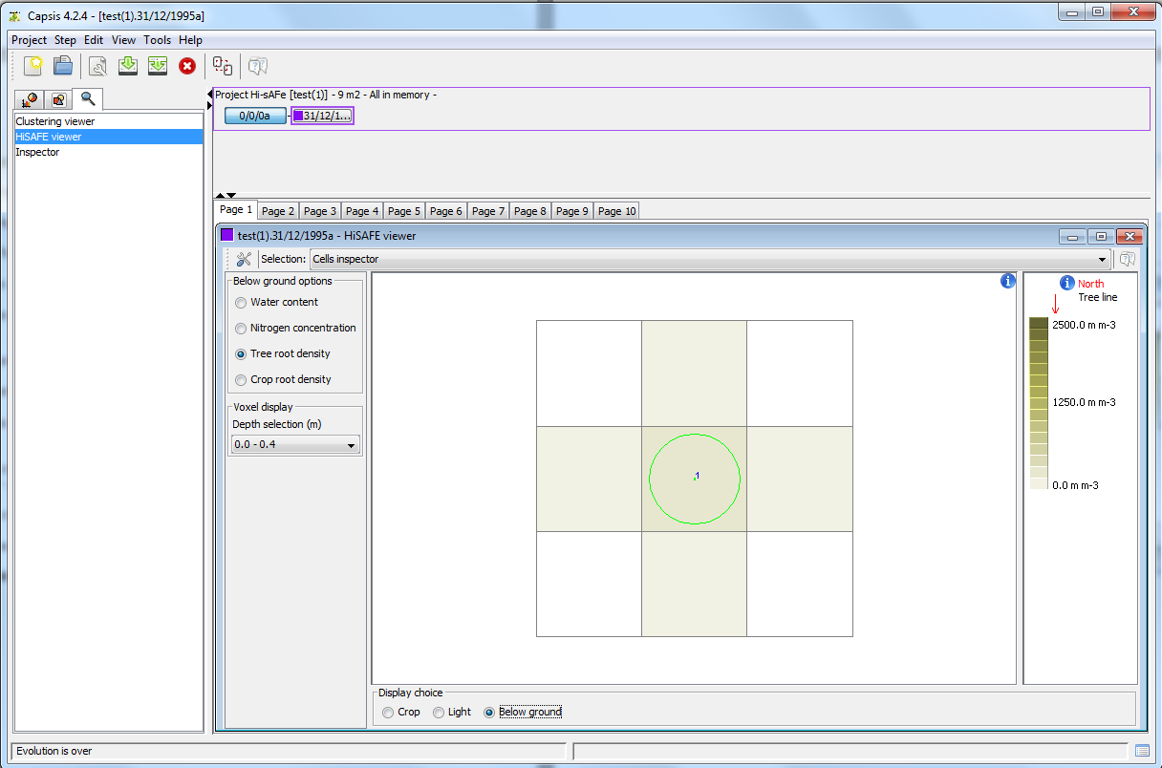

To see other steps, right-click on a step and choose “**Configure**”

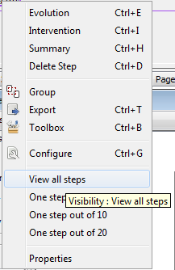

Results can be graphically explored using the **Inspector** or **HiSAFE viewer**

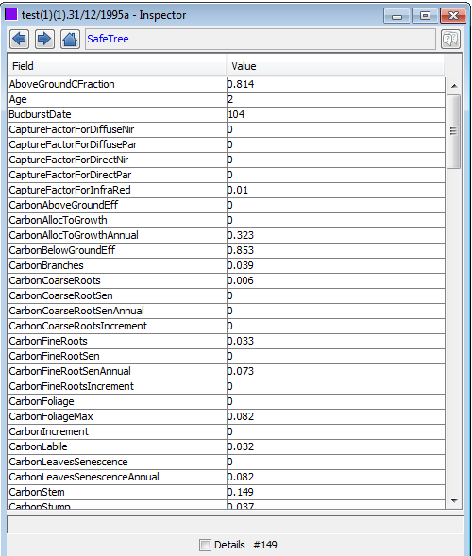

## BATCH mode

Copy the capsis4/data/safe/ in a user simulation folder with

* **cropInterventions :** folder with all crop management files needed for the simulation
* **cropSpecies** : folder with all crop species file used in the simulation
* **exportParameters :** folder with all export profiles needed for the simulation
* **generalParameters** : folder with the general parameter file
* **treeSpecies** : folder with all tree species parameters files needed for the simulation
* **test.sim :** simulation parameter file

Copy the **plot file** (*.pld) and the **weather file** (*.wth) in the simuation folder. Hi-sAFe will found them automatically thanks to their extension.

Be advised to choose a disk volume with enough space because a long simulation can generate large output files.

In this example simulation folder is **D:/simulations/test**

The simulation parameter file (test.sim) contains all information to run the simulation (this corresponding to the user entries in GUI mode)

Open a DOS prompt and execute

> capsis –p script safe.pgms.ScriptGen D:/simulations/test/test.sim

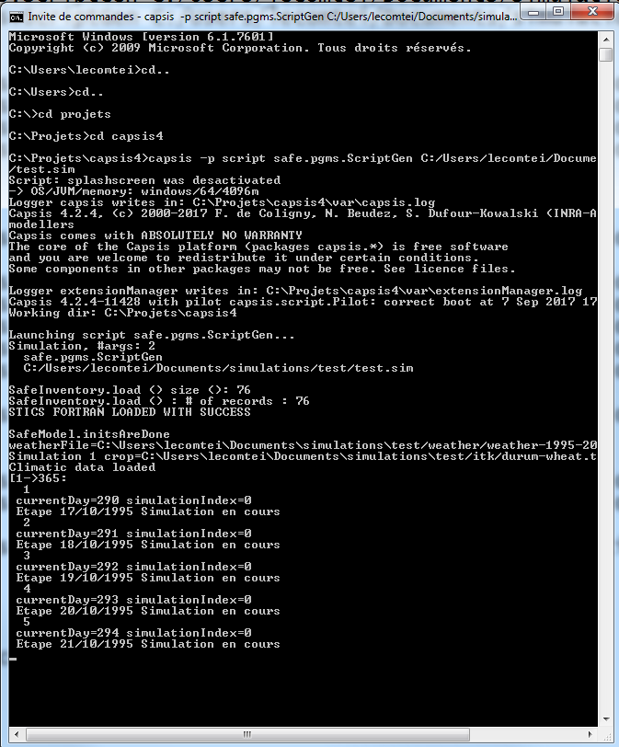

Starting messages for BATCH execution mode

Execution will automatically generate an output folder named **output-test.sim** containing**:**

* initialisation.sti : message from STICS initialisation
* mainplant.sti : message for STICS main plan initialisation
* secondplant.sti : message for STICS main plan initialisation
* one cvs file for each export described in the simulation parameter file

|  |  |  |
| --- | --- | --- |
| **Name** | **Definition** | **Unit** |
| ## SIMULATION |  |  |
| nbSimulations | Number of simulations (i.e. number of years to simulate) | - |
| simulationYearStart | Simulation year start. This year must be present in the weather file. | Year |
| simulationDayStart | Simulation day of year start. Care must be taken when specifying this value to ensure that, for annual crops, all crop activities (sowing, fertilization, irrigation, tillage, harvest, etc.) must occur within 1 year of this day. For example, if the simulation starts on day 1 (Jan 1), but winter wheat is not sown until day 350, then the crop will only grow for 15 days, with whatever grop is growing in simulation year 2 being initialized at that point. Therefore, the simulation should begin only a short time before the sowing of the initial crop. | DOY |
| simulationNbrDays | Number of days per simulation to run (separated with , to change this for each simulation run). Normally, this is left at 365 so that each STICS "simulation" spans a full year. However, shorter values can be used to run multiple crops per year, although in this case unit for simulation length is no longer 1 year. | days |
| saveProjectOption | Option to save project file at end of simulation, which allows continuing a new simulation from this point. | 0 = no, 1 = yes |
| projectFileName | The name of the prj file (exported by a previous Hi-sAFe simulation) from which to initialize this simulation. This is a relative path to the simulation folder. | - |
| debugMode | If 1, prints daily outputs to log file. If 0, only annual outputs are printed to log file. | - |
| sticsReport | If 1, a STICS simulation report is exported for each cell in each year. If 0, the reports are not exported. Reports are exported one per year per cell. These reports contain annual water and nitrogen budgets, among other metrics. Exporting reports drastically slows simulations. | - |
| ## CROP ROTATION |  |  |
| mainCropSpecies | Name of the main alley crop plt file. Crop sucession/rotation can be generated by using , to separate multiple file names. | - |
| interCropSpecies | Name of the interCrop plt file for the "leave area" within the tree rows. Crop sucession/rotation can be generated by using , to separate multiple file names. | - |
| mainCropItk | Name of the main alley crop tec file. Crop sucession/rotation can be generated by using , to separate multiple file names. The tec files used here will be applied in the designated year regardless of if the name matches the corresponding plt file. | - |
| interCropItk | Name of the interCrop tec file for the "leave area" within the tree rows. Crop sucession/rotation can be generated by using , to separate multiple file names. The tec files used here will be applied in the designated year regardless of if the name matches the corresponding plt file. | - |
| treeCropDistance | Perpendicular distance from the tree, within which is interCrop and beyond which is mainCrop. If this distance does not end on a cell boundary, the distance is rounded up to the next cell boundary. | m |
| treeCropRadius | Radius around the tree, within which is interCrop and outside of which is mainCrop. If this distance does not end on a cell boundary, the distance is rounded up to the next cell boundary. The method using treeCropDistance takes priority - if treeCropDistance > 0, treeCropRadius is ignored. | m |
| ## EXPORTS |  |  |
| profileNames | Name of profiles to export | - |
| exportFrequencies | Export frequencies for each profile | 1=each day, 30=each month, 365=each year |
| ## TORIC SYMMETRY |  |  |
| toricXp | Toric symetry of X axis in the positive direction | 0 = off; 1 = on |
| toricXn | Toric symetry of X axis in the negative direction | 0 = off; 1 = on |
| toricYp | Toric symetry of Y axis in the positive direction | 0 = off; 1 = on |
| toricYn | Toric symetry of Y axis in the negative direction | 0 = off; 1 = on |
| ## TREE PLANTING |  |  |
| treePlantingYears | Years in which tree planting occurs (separated by ,). Values are applied to trees in the order they are present in the tree initialization table. If extending from a .PRJ file, the year numbering continues from that base simulation! | simulation year |
| treePlantingDays | Days of year on which tree planting occurs (separated by ,). Values are applied to trees in the order they are present in the tree initialization table. | day of year |
| ## TREE PRUNING |  |  |
| treePruningYears | Years in which tree pruning occurs (separated by ,). If extending from a .PRJ file, the year numbering continues from that base simulation! | simulation year |
| treePruningDays | Tree pruning days (separated by ,) | DOY |
| treePruningProp | Proportion of tree height (bottom part of tree) on which branches are pruned (separated by ,) | proportion |
| treePruningMaxHeight | Tree pruning maximum height (separated by ,) | m |
| treeDensityReduction | Proportion of branches & leaves that are removed (while keeping the crown volume constant) (separated by ,) | proportion |
| ## TREE THINNING |  |  |
| treeThinningIds | Tree IDs to thin (separated by ,) | tree id |
| treeThinningYears | Years in which tree thinning occurs (separated by ,). If extending from a .PRJ file, the year numbering continues from that base simulation! | simulation year |
| treeThinningDays | Day on which tree thinning occurs (separated by ,) | DOY |
| ## TREE ROOT PRUNING |  |  |
| treeRootPruningYears | Years in which root pruning occurs (separated by ,). If extending from a .PRJ file, the year numbering continues from that base simulation! | simulation year |
| treeRootPruningDays | Days on which root pruning occurs (separated by ,) | DOY |
| treeRootPruningDistance | Perpendicular horizontal distance from the tree row at which root pruning occurs (separated by ,) | m |
| treeRootPruningDepth | Depth from soil surface to which root pruning occurs (separated by ,). Maximum value is the maximum soil depth. | m |
| ## TREE LITTER INCORPORATION IN SOIL |  |  |
| treesLeafLitterIncorporated | Toggle on/off for the incoproration of tree leaf litter into soil. If 1, tree leaf litter is incorporated into the soil and nutrient cycling dynamics. If 0, tree leaf litter disappears from the system. | 0 = off; 1 = on |
| treesRootLitterIncorporated | Toggle on/off for the incoproration of shallow (above humificationDepth) tree root litter into soil. If 1, shallow tree root litter is incorporated into the soil and nutrient cycling dynamics. If 0, shallow tree root litter disappears from the system. | 0 = off; 1 = on |
| treesDeepRootLitterIncorporated | Toggle on/off for the incoproration of deep (below humificationDepth) tree leaf root into soil. If 1, deep tree root litter is incorporated into the soil and nutrient cycling dynamics. If 0, deep tree root litter disappears from the system. | 0 = off; 1 = on |

Table 1: Format for simulation parameters file

**Crop rotation examples :**

Simulation parameter file can integrate crop rotations like:

nbSimulations = 10

mainCropSpecies = durum-wheat(3), rape(2)

interCropSpecies = baresoil, weed

treeCropDistance = 0.5(5),1.0(5)

For 10 years of simulation the rotation will be:

Main crop: durum-wheat / durum-wheat / durum-wheat / rape / rape / durum-wheat / durum-wheat / durum-wheat / rape / rape

Inter crop: Baresoil / Weed / Baresoil / Weed / Baresoil / Weed / Baresoil / Weed / Baresoil / Weed

Tree Crop distance: 0.5 / 0.5 / 0.5 / 0.5 / 0.5 / 1.0 / 1.0 / 1.0 / 1.0 / 1.0

# Exporting Hi-sAFe results

## GUI mode

The best way to explore simulation results is to the export ASCII files output to be treated with EXCEL , R or any other data management software.

1) Right-click on the last step on the simulation and choose the “**Export**” option

2) Choose the **SafeExportation** format and give the ASCII file a name

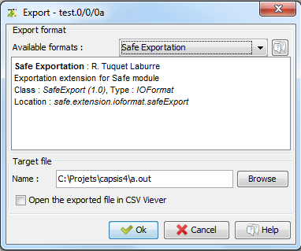

3) Choose an existing profile or create a new one if necessary

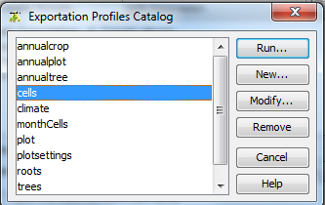

4) A profile contains all the information necessary to export data from the simulation.

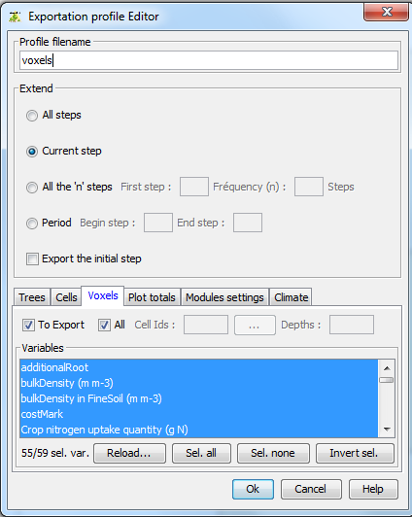

Depth selection

Cell selection

Profile name

Data selection

Step to export

5) A graphical selector is available for cell choice

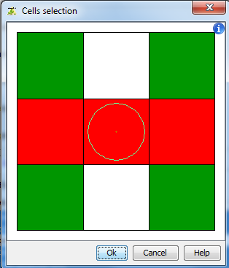

6) When exportation process is running, a progress bar is displayed

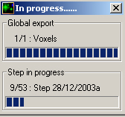

7) Export ASCII file example

# Capsis 4.1.5 generated file - Thu Jul 20 11:47:09 CEST 2006

# Profil d'exportation

> Nom du fichier-profil : C:\capsis4\bin\safe\data\exportParameters\Cells

> Etendue : Toutes les étapes

> Exporter l'étape initiale : Oui

> Cellules : Tout (8 Variables)

> Variables :

Sujet IdSujet NomVariable Unité Description

SafeCell Cellules waterDemand liters Eau demandée par la culture

SafeCell Cellules reducedWaterDemand liters Eau demandée par la culture (reduction cambell)

SafeCell Cellules waterUptake liters Eau extraite par la culture

SafeCell Cellules rootDepth m Profondeur des racines

SafeCell Cellules waterStress - Stress hydrique culture

SafeCell Cellules sticsWaterTurgescenceStress - Stress hydrique de turgescence

SafeCell Cellules sticsWaterStomatalStress - Stress hydrique stomatique

SafeCell Cellules sticsWaterSenescenceStress - Stress hydrique sur senescence

# Cellules

Date stepNum id x y waterDemand reducedWaterDemand waterUptake rootDepth waterStress sticsWaterTurgescenceStress sticsWaterStomatalStress sticsWaterSenescenceStress

27/10/2003 1 0 0.0 0.0 0.0 0.0 0.0 0.0 1.0 1.0 1.0 1.0

27/10/2003 1 1 0.0 0.0 0.0 0.0 0.0 0.0 1.0 1.0 1.0 1.0

28/10/2003 2 0 0.0 0.0 0.0 0.0 0.0 0.0 1.0 1.0 1.0 1.0

28/10/2003 2 1 0.0 0.0 0.0 0.0 0.0 0.0 1.0 1.0 1.0 1.0

29/10/2003 3 0 0.0 0.0 0.0 0.0 0.0 0.0 1.0 1.0 1.0 1.0

29/10/2003 3 1 0.0 0.0 0.0 0.0 0.0 0.0 1.0 1.0 1.0 1.0

30/10/2003 4 0 0.0 0.0 0.0 0.0 0.0 0.0 1.0 1.0 1.0 1.0

30/10/2003 4 1 0.0 0.0 0.0 0.0 0.0 0.0 1.0 1.0 1.0 1.0

31/10/2003 5 0 0.0 0.0 0.0 0.0 0.0 0.0 1.0 1.0 1.0 1.0

31/10/2003 5 1 0.0 0.0 0.0 0.0 0.0 0.0 1.0 1.0 1.0 1.0

## Batch mode

In BATCH mode export files are automatically generated in the output folder according to rules written in the simulation file.

#EXPORTS

profileNames = annualplot,annualtree,climate,plot,trees,cells,voxels

exportFrequencies = 365,365,1,1,30,30

Be advised to create the export profile with the GUI interface and to copy the *.pro files in the simulation exportParameters folder.

More details about the export profile in chapter 5.4.

# Hi-sAFe input files description

All files are in **CSV ASCII** format that can be edited with standard editing software such as NotePad, TextPad or Microsoft Excel.

Comments are always preceded by the special character # and most of the times are in capital letters

#PLOT DESCRIPTION

Single data are formatted as keyword = value with only a space (not tabulation) between them.

elevation = 130

Numbers are in US format

latitude = 43.7

String doesn’t need to be notified with special quotation marks.

township = Montpellier

Boolean values are true or false

waterTable = true

List data are separated by tabulations with an identifying keyword in the first column. Lines of comment should always explain what the columns contain and their units.

#LAYER INITIALISATION

# waterContent n03Concentration nh4concentration

# % kg ha-1 kg ha-1

LayerInit 0.10 32.0 0.0

LayerInit 0.10 12.0 0.0

The Hi-sAFe model loads input files before running a simulation. If a modification is done in one file, the user doesn’t have to close Capsis and reload Hi-sAFe to take the modification into account. He or she will only need to run a new simulation.

These file names, extensions and physical locations can be changed but our advice is to give explicit names and extensions to easily recognise these files and their use.

## Plot description (*.pld)

The plot description will give all information about the virtual scene (dimensions, orientation, tree spacing, soil characteristics etc.)

Name and extension can be changed, but our advice is to call these files with the real explicit name of your experimental plot and .pld extension (example: restincliere-A2.pld)

|  |  |  |
| --- | --- | --- |
| **Name** | **Definition** | **Unit** |
| ## PLOT |  |  |
| latitude | Latitude | degrees (negative is south of equator) |
| elevation | Elevation above sea level | m |
| cellWidth | Cell width | m |
| northOrientation | Orientation of North. The tree row is always parallel to the Y axis. | degrees clockwise relative to the the +Y axis of the scene |
| plotHeight | Plot height (y). | m |
| plotWidth | Plot width (x). | m |
| slopeIntensity | Magnitude of the slope of the soil surface (only used by the light module) | degrees downward from horizontal |
| slopeAspect | Aspect of the slope of the soil surface (only used by the light module) | degrees clockwise from North that the slope goes downward |
| ## SOIL |  |  |
| voxelThicknessMax | Maximum allowed thickness of a voxel when automatically splitting specified layers into voxels. | m |
| humificationDepth | Depth of soil humification zone (soil depth with an active biological activity). | m |
| albedo | Albedo for dry bare soil | ratio |
| cropRootObstruction | Soil depth at which CROP root growth is stopped due to physical constraints | m |
| ph | Initial soil pH (water solution). Applies to all soil layers. | unitless |
| swellingClaySoil | Toggle on/off the option to activiate an additional water compartment for swelling soils | 0 = off; 1 = on |
| macroporosity | Toggle on/off the calculation of water flux in soil macroporosity | 0 = off; 1 = on |
| soilCrustDepth | Mulch depth from which a crust occurs (inactive if the STICS vigueurbat parameter is equal to 1) | cm |
| roughnessLength | Roughness length of bare soil | m |
| soilHumusCN | Initial C to N ratio of soil organic matter from the surface down to the humificationDepth. Used to initialize soil organic carbon via organicNitrogen. | ratio |
| ## WATER |  |  |
| waterTable | Toggle on/off the inclusion of a water table | 0 = off; 1 = on |
| evaporationValue | Cumulative soil evaporation above which evaporation rate is decreased | mm |
| evaporationMaxDepth | Maximum soil depth affected by soil evaporation | cm |
| evaporationDepthContribution | Parameter defining the soil contribution to evaporation versus depth | unitless |
| runOffCoefPlantMulch | Runoff coefficient taking account for plant mulch | unitless |
| rainRunOffFraction | Run off fraction (relative to total rainfall) in bare soil | ratio |
| capillary | Toggle on/off the inclusion of capillary rise at the base of the soil profile. Only used if macroporosity == 1 as well. | 0 = off; 1 = on |
| capillaryUptake | Capillary rise upward water flux. Only used if capillary == 1 and macroporosity == 1. | mm day-1 |
| capillaryUptakeMinWater | Threshold of soil gravimetric water content under which capillary rise occurs. Only used if capillary == 1 and macroporosity == 1. | g water / g soil |
| artificialDrainage | Toggle on/off the inclusion of artificial drainage (pipes). Only used if macroporosity == 1 as well. | 0 = off; 1 = on |
| drainagePipesSpacing | Spacing between artificial drainage pipes. Only used if artificialDrainage == 1 and macroporosity == 1. | m |
| drainagePipesDepth | Depth (from the soil surface) of artificial drainage pipes. Only used if artificialDrainage == 1 and macroporosity == 1. | m |
| waterConductivity | Soil hydraulic conductivity in the vicinity of artificial drainage pipes (for water moving into drainage pipes). Only used if artificialDrainage == 1 and macroporosity == 1. | unitless |
| impermeableLayerDepth | Upper depth of the impermeable layer (from the soil surface). May be greater than the soil depth. Only used if artificialDrainage == 1 and macroporosity == 1. | m |
| ## NITROGEN |  |  |
| organicNitrogen | Initial soil organic N content in the soil layer from the surface down to humificationDepth. | proportion of of fine soil |
| minNo3Concentration | Soil minimum NO3 concentration | kg N ha-1 mm-1 |
| nitrification | Toggle on/off the calculation of nitrification. If true, nitrification is calculated daily. If false, all NH4 is assumed to be nitrified to NO3 each day. | 0 = off; 1 = on |
| denitrification | Toggle on/off to activate a more mechanistic calculation of denitrification via the NEMIS model. | 0 = off; 1 = on |
| denitrificationDepth | Soil depth on which denitrification is active. Only used if denitrification == 1. | cm |
| denitrificationRate | Potential rate of denitrification for the whole denitrifying layer. Only used if denitrification == 1. | kg N ha-1 day-1 |
| no3ConcentrationInWaterTable | Fixed concentraiton of NO3 in water table. Only used if waterTable == 1. | g L-1 |
| nh4ConcentrationInWaterTable | Fixed concentraiton of NH4 in water table. Only used if waterTable == 1. | g L-1 |
| ## LAYERS  # Maximum of FIVE layers for Hi-sAFe and STICS | | |
| thick | Layer thickness | m |
| sand | Sand content of soil layer (MUST INCLUDE DECIMAL AND AT LEAST ONE NUMBER AFTER DECIMAL) | % of fine soil |
| clay | Clay content of soil layer (MUST INCLUDE DECIMAL AND AT LEAST ONE NUMBER AFTER DECIMAL) | % of fine soil |
| limestone | Limestone content of soil layer (MUST INCLUDE DECIMAL AND AT LEAST ONE NUMBER AFTER DECIMAL) | % of fine soil |
| organicMatter | Organic matter content of soil layer. This is only used for the calculation of bulk density. It is NOT used to initialize soil carbon content. (MUST INCLUDE DECIMAL AND AT LEAST ONE NUMBER AFTER DECIMAL) | % of fine soil |
| partSizeSand | Particle size of sand | micrometers |
| stone | Stone content of soil layer | % by volume of bulk soil |
| stoneType | Stone type. This affects the density of the stone and it's water absorption capacity. | 1=limestone B1, 2=limestone B2, 3=limestone L, 4=scree L, 5=gravel m, 6=flint, 7=granite a, 8=limestone J, 9=other1, 10=other2 |
| infiltrability | Infiltrability rate at the base of each soil layer. Only used if macroporosity == 1. To simulate a layer that is impermeable to water fluxes, this value can be set very low. | mm day-1 |
| ## LAYER INITIALIZATION | | |
| waterContent | Initial water content of soil layer (in fine soil) | ratio |
| no3Concentration | Initial NO3-N concentration of soil layer (in fine soil) | kg N ha-1 |
| nh4concentration | Initial NH4-N concentration of soil layer (in fine soil) | kg N ha-1 |
| ## TREE INITIALIZATION  # Parameter names are not used within the pld file. Columns are without headers. Only column order matters. | | |
| species | Tree species name. This must patch the name of the .tree file, but does not include ".tree" here. | - |
| height | Initial tree height | m |
| crownBaseHeight | Initial crown base height | m |
| leafToFineRootsRatio | Initial ratio of leaf to fine root biomass | kg kg-1 |
| crownRadius | Initial crown radius (in both the x and y directions) | m |
| treeX | Tree position on scene X-axis. If (0,0) is used for treeX and treeY, the tree is instead automatically palced at the X,Y CENTER of the scene. Trees must be planted in the center of a cell. Only one tree can be planted in each cell. | m (from plot X,Y origin at the bottom-left of the plot) |
| treeY | Tree position on scene Y-axis. If (0,0) is used for treeX and treeY, the tree is instead automatically palced at the X,Y CENTER of the scene. Trees must be planted in the center of a cell. Only one tree can be planted in each cell. | m (from plot X,Y origin at the bottom-left of the plot) |
| ## ROOT INITIALIZATION  # Parameter names are not used within the pld file. Columns are without headers. Only column order matters. | | |
| shape | Initial shape of tree root volume. A set of voxels are selected to include initial root biomass using this shape. | 1=Sphere; 2=Ellipsoid; 3=Cone |
| repartition | Method for initial allocation of fine root biomass among the voxels selected for root initialization via the shape parameter. | 1=Uniform; 2=Inverse proportional to distance; 3=Negative exponential |
| paramShape1 | Parameter 1 for root initialization.  For Sphere: radius of sphere For Ellipsoid: radius of ellipsoid in X direction For Cone: radius of cone base | m |
| paramShape2 | Parameter 2 for root initialization.  For Sphere: NOT USED For Ellipsoid: radius of ellipsoid in Y direction For Cone: depth of cone | m |
| paramShape3 | Parameter 3 for root initialization.  For Sphere: NOT USED For Ellipsoid: radius of ellipsoid in Z direction For Cone: NOT USED | m |

Table 2: List of plot description input data

## Crop interventions (*.tec)

This file will give all information about interventions planed for a crop on the virtual scene (sowing date, soil management, irrigation, fertilisation etc.)

Name and extension are free but one advice is to call these files with the name of the crop species - the real explicit name of your experimental plot with .tec extension (example: wheat-restincliere-A2.tec)

|  |  |  |
| --- | --- | --- |
| **Name** | **Definition** | **Unit** |
| #SOIL MANAGEMENT |  |  |
| nbjtrav | Number of soil management item |  |
| nbjres | Number of soil of residue incorporation |  |
| julres | Date of soil residue incorporation | DOY |
| coderes | type of residue | 1=crop residues, 2=CI residues, 3=animal waste, 4=OM compost, 5=SE mud, 6=grape waste, 7=horn, 8=other |
| qres | quantity of crop residues or organic inputs provided to the soil (fresh materials) | t fresh material ha-1 |
| Crespc | proportion of carbon in residues |  |
| CsurNres | C/N ratio of crop residues or organic inputs |  |
| Nminres | mineral N content of organic residues | % fresh material |
| eaures | water content of organic residues | % fresh material |
| jultrav | Date of soil management | DOY |
| profres | minimum depth of residue incorporation | cm |
| proftrav | depth of tillage and/or incorporation of organic residues (max. 40 cm) | cm |
| #SOWING OPTIONS |  |  |
| iplt0 | Date of sowing | DOY |
| profsem | Depth of sowing | cm |
| densitesem | Density of sowing | nb plants m-2 |
| variete | Variety | 1-n |
| codetradtec | description of crop structure with use of radiation transfer | 1 = yes, 2 = no |
| interrang | width of the crop interrow | m |
| orientrang | direction of crop rows (relative to north) | rad |
| codedecisemis | option to activate the moisture effect on harvest decision | 1 = yes, 2 = no |
| nbjmaxapressemis | maximal delay allowed for sowing (number of days) (if the soil compaction option is activated) |  |
| nbjseuiltempref | number of days without frost for sowing (if sowing decision option is activated) |  |
| #STAGE FORCING |  |  |
| codestade | option: forcing of one or more developmental stages | 1 = yes, 2 = no |
| ilev | Julian day of LEV stage (emergence) if this stage is observed (if not, 999) | DOY |
| iamf | Julian day of AMF stage (maximum acceleration of leaf growth, end of juvenile phase) if this stage is observed (if not, 999) | DOY |
| ilax | Julian day of LAX stage (maximum leaf index) if this stage is observed (if not, 999) | DOY |
| isen | Julian day of SEN stage (clear onset of senescence) if this stage is observed (if not, 999) | DOY |
| ilan | Julian day of LAN stage (no leaf index) if this stage is observed (if not, 999) | DOY |
| iflo | Julian day of flowering stage if this stage is observed (if not, 999) | DOY |
| idrp | Julian day of DRP stage (beginning of grain filling) if this stage is observed (if not, 999) | DOY |
| imat | Julian day of MAT stage (physiological maturity) if this stage is observed (if not, 999) | DOY |
| irec | Julian day of REC stage (harvest) if this stage is observed (if not, 999) | DOY |
| irecbutoir | latest date of harvest (imposed if the crop cycle is not finished at this date) | DOY |
| #IRRIGATION |  |  |
| nap | Number of irrigation item |  |
| julapI | Irrigation date | DOY |
| qte | Quantity of water | mm |
| effirr | irrigation efficiency |  |
| codecalirrig | code to activate the automatic calculation of irrigation requirements | 1 = yes, 2 = no |
| ratiol | water stress index below which irrigation is started in automatic mode | 0 in manual mode |
| dosimx | maximum water amount of irrigation authorised at each time step (mode automatic irrigation) | mm d-1 |
| doseirrigmin | minimal amount of irrigation | mm |
| codedateappH2O | irrigation application dates given as sum of temperatures | 1 = yes, 2 = no |
| codlocirrig | code of irrigation localisation: | 1= above the foliage, 2= below the foliage above the soil, 3 = in the soil |
| locirrig | soil depth at which irrigation is applied | cm |
| profmes | depth of measurement of the soil water reserve | cm |
| #FERTILISATION |  |  |
| engrais | type of fertiliser | 1= ammonium sulphate, 2=ammonium nitrate, 3= ammonium nitrate + calcium, 4= anhydrous ammonia, 5=urea, 6=di-ammonium phosphate, 7=solution, 8=other |
| concirr | concentration of mineral N (NH4+NO3-N) in irrigation water | kg ha-1 mm-1 |
| codedateappN | mineral fertilizer application dates given as sum of temperatures | 1 = yes, 2 = no |
| codefracappN | option to activate splitting applications of N fertiliser | 1 = absolute value, 2 = % of total value |
| Qtot_N | If codefracappN = 2, this is the total amount of mineral N in all fertilizer applications, and then values of qte below are percentages. | Kg N ha-1 |
| napN | Number of fertilisation item |  |
| julapN | Fertilisation date | If codedateappN = 1: sum of temperatures If codedateappN = 2: DOY |
| qte | Fertiliser quantity | If codefracappN = 1: Kg N ha-1 If codefracappN = 2: percentage of Qtot_N |
| codlocferti | option to code of fertilisation localisation | 1= on soil surface, 2 = in soil |
| locferti | soil depth at which fertiliser is applied | cm |
| #HARVEST |  |  |
| codrecolte | Option for triggered harvest | 1=physiologic maturity 2=water content 3=sugar 4=nitrogen 5=oil |
| ressuite | Type of residue after harvest | Pool names |
| codceuille | option of harvest type | 1 =single harvest (cutting), 2 = multiple harvests (picking) |
| nbceuille | number of fruit harvestings | 1= one at the end, 2 = many during the cycle |
| cadencerec | number of days between two harvests |  |
| codeaumin | option to activate the harvest as a function of grain/fruit water content | 1=minimum 2=maximum |
| h2ograinmin | min water content in fruits at harvest | g water g MF -1 |
| h2ograinmax | max water content in fruits at harvest | g water g MF -1 |
| sucrerec | min sugar content at harvest | g MF -1 |
| CNgrainrec | nitrogen concentration in grains for harvest | 0-1 |
| huilerec | min oil content at harvest | g oil g MF -1 |
| coderecolteassoc | option to harvest intercrop species simultaneously, at the physiological maturity date of the earliest one | 1 = no, 2 = yes |
| codedecirecolte | option to activate moisture and frost effects on harvest decision | 1 = yes, 2 = no |
| nbjmaxapresrecolte | maximal delay allowed for harvest (number of days) (if the soil compaction option is activated) |  |
| #CUTTINGS |  |  |
| codefauche | option to activate cuts of forage crops | 1=yes 2=no |
| mscoupemini | minimum value of aerial biomass required to make a cut of forage crop |  |
| codemodfauche | option defining the cut mode | 1 = automatic calculation depending on phenologic and trophic state, 2 = pre-established calendar in days, 3 = pre-established calendar in degree-days |
| hautcoupedefaut | cut height for forage crops (calendar calculated) | m |
| stadecoupedf | stage of automatic cut for forage crops |  |
| nbcoupe | Number of cuttings |  |
| julfauche | date(s) of each cut for forage crops | DOY |
| hautcoupe | cut height for forage crops (calendar fixed) | m |
| lairesiduel | residual LAI after each cut of forage crop | m2 leaves m-2 soil |
| msresiduel | Dry matter residual after each cut of forage crop | t ha-1 |
| anitcoupe | amount of mineral N added by fertiliser application at each cut of a forage crop | kgN ha-1 |
| mulchInitialQte | Initial quantity of mulch | t ha-1 |
| #OTHERS |  |  |
| codepaillage | mulch option | 1=no 2=plant 3=plastic |
| couvermulchplastique | fraction of soil covered by the plastic mulch |  |
| albedomulchplastique | albedo of plastic cover |  |
| codrognage | option of foliage control by trimming | 1 = no, 2 = yes |
| largrogne | trimmed width | m |
| hautrogne | cutting height for trimmed plants | m |
| biorognem | minimal biomass to be removed when topping (automatic calculation) | t ha-1 |
| codcalrogne | option of calculation of tipping | 1 = forced topping, 2 = automatic calculation |
| julrogne | day of plant trimming |  |
| margerogne | topping occurs when plant height exceeds (hautrogne+margerogne) when automatic trimming is activated |  |
| codeclaircie | option for the method of fruit removal | 1 = no, 2 = yes for smallest fruits |
| juleclair | day of fruits removal |  |
| nbinfloecl | number of inflorescences or fruits removed at fruit removal | nb pl-1 |
| codeffeuil | option to activate thinning | 1 = no, 2 = yes |
| codhauteff | option of leaf removal height | 1 = bottom of the canopy, 2 = top of the canopy |
| codcaleffeuil | option for the method to use for the calculation of leaf removal | 1 = no, 2 =yes |
| laidebeff | LAI of the beginning of leaf removal | m2 m-2 |
| effeuil | fraction of daily leaf removed at thinning |  |
| juleffeuil | day of leaf removal |  |
| codepalissage | option defining if the plant is fixed onto a vertical suuport (palissage) | 1 = no, 2 =yes |
| hautmaxtec | maximal height of the plant allowed by the management |  |
| largtec | technical width | m |
| codabri | option to activate cropping under shelter | 1 = no, 2 = yes |
| transplastic | transmission coefficient of the plastic shelter |  |
| surfouvre1 | relative area of the shelter opened the first day of opening |  |
| julouvre2 | day (1/2) of opening the shelter |  |
| surfouvre2 | relative area of the shelter opened the second day of opening |  |
| julouvre3 | day (2/2) of opening the shelter |  |
| surfouvre3 | relative area of the shelter opened the third day of opening |  |
| codeDST | option to activate the variations in soil physical soil conditions due to tillage | 1 = yes, 2 = no |
| dachisel | bulk density of soil after soil tillage (Chisel) | g cm-3 |
| dalabour | bulk density of soil after full inversion tillage (plough) | g cm-3 |
| rugochisel | roughness length of bare soil after chisel tillage (if soil compaction is activated) | m |
| rugolabour | roughness length of bare soil after mouldboard ploughing (if soil compaction is activated) | m |
| codeDSTtass | option to activate the soil compaction at sowing and harvest | 1 = yes, 2 = no |
| profhumsemoir | soil depth at which moisture is considered to allow sowing (if soil compaction is activated) | cm |
| dasemis | bulk density of soil after sowing |  |
| profhumrecolteuse | soil depth at which moisture is considered to allow harvesting (if soil compaction is activated) | m |
| darecolte | bulk density of soil after harvest |  |
| codeDSTnbcouche | number of compacted soil layers | 1 = one layer, 2 = two layers |
| ## PERENNIAL CROP INIT |  |  |
| initialCropStage | Crop stage at initialization | 1 = snu; 2 = plt; 3 = dor; 4 = lev; 5 = amf; 6 = lax; 7 = flo; 8 = drp; 9 = des ; 10 = mat ; 11 = rec; 12 = sen; 13 = lan |
| initialCropLai | Leaf area index at initialization | m2 m-2 |
| initialCropBiomass | Crop biomass at initialization | t ha-1 |
| initialCropRootDepth | Crop root depth at initialization | m |
| initialCropGrainBiomass | Crop grain biomass at initialization | g m-2 |
| initialCropNitrogen | Crop total nitrogen content at initialization | kg N ha-1 |
| initialCropReserveBiomass | Crop reserve biomass at initialization | t ha-1 |
| initialCropRootDensity | Table of initial root density at initialization. One value for each soil layer, separated by commas. | cm cm-3 |

Table 3: List of crop intervention input data

## Weather data (*.wth)

Hi-sAFe simulation in interactive mode cannot exceed 365 days, so weather data file doesn’t need to be more than 365 days either. It is sometimes necessary to store several years of weather data in the same file to run winter cropped plots simulations (for example durum wheat seeded in October and harvested in June the next year)

For batch execution a weather file covering the whole simulation duration have to be provided. By default Hi-sAFe provides capsis4\data\safe\weather\weather-1995-2035.wth corresponding to 40 years of French Mediterranean climate. Last 20 years have been randomly generated with previous ones.

Name and extension are free but one advice is to call these files with the real explicit name of your weather station – start year – end year - with .wth extension (example: restinclieres-1996-2014.wth)

|  |  |  |
| --- | --- | --- |
| **Name** | **Definition** | **Unit** |
| Julian Day | Number of the day in the year | - |
| Year | Year | actual calendar year |
| Month | Month | - |
| day | Day of month | - |
| Maximum Temperature | Maximum temperature | degreeC |
| Minimum Temperature | Minimum temperature | degreeC |
| Maximum Relative Humidity | Maximum relative humidity | % |
| Minimum Relative Humidity | Minimum relative humidity | % |
| Global Radiation | Global radiation (longwave + shortwave) | MJ m-2 |
| Precipitation | Precipitation (rain or snow) | mm |
| Mean Wind Speed | Mean wind speed (at measurement height zr above) | m s-1 |
| Water Table Depth | Water table depth from soil surface (numbers are negative) | m |
| Atmospheric [CO2] | Atmospheric CO2 concentration (only used for CROPS if codeclichange above is 2; TREES do not sense [CO2] in Hi-sAFe) | ppm |

Table 4 : List of weather input data

## Export profile (*.pro)

It is more convenient and secure to create and update the export profiles with the Hi-sAFe GUI interface. In BATCH mode, export profiles have to be in the exportProfile folder of the simulation.

Refer to the Excel file Hi-sAFe - V3-1 - Parameter Details to get all the export variable available.

# Hi-sAFe parameters files description

Name and location of the parameters files have been fixed by the authors and cannot be modified without a complete recompilation of the model. There is no graphical interface for visualizing or modifying them. However it is possible to modify data in these files (to test different parameters values) using standard editing software.

Hi-sAFe loads these files once during the initialisation and all these data are unchanged as soon as Capsis is running. If a modification is made in a parameter file the user has to close Capsis and reload the whole Hi-sAFe model.

**Neither names nor physical location of these parameter files can be modified!**

## Tree species parameters (*.tree)

3 species are available in Hi-sAFe model, these species are poplar, wild cherry and walnut hybrid.

|  |  |  |
| --- | --- | --- |
| **Name** | **Description** | **Unit** |
| ## GENERIC |  |  |
| treeSpecies | Name of tree species | - |
| ## ALLOMETRY |  |  |
| crownShape | Crown shape code (PARABOLOID NOT IMPLEMENTED) | 1=ellipsoid; 2=paraboloid |
| ellipsoidTruncationRatio | Ratio for calculating ellipsoid truncation. A value of 0 means that the shape is a full/true ellipsoid -- verticalCrownRadius = ((height - crownBaseHeight) / (1 - truncatureRatio))/2. Only used when crownShape == 1. | ratio |
| #height vs. DBH |  |  |
| heightDbhAllometricCoeffA | Parameter A for the allometric relationship between height and DBH: height = A * DBH^B (height & DBH in meters) | - |
| heightDbhAllometricCoeffB | Parameter B for the allometric relationship between height and DBH: height = A * DBH^B (height & DBH in meters) | - |
| #crownArea vs. DCB |  |  |
| crownDbhAllometricCoeffA | Parameter A for the allometric relationship between crown area and DCB: crownArea = A * DCB ^B (cornwArea & DCB in meters) | - |
| crownDbhAllometricCoeffB | Parameter B for the allometric relationship between crown area and DCB: crownArea = A * DCB ^B (cornwArea & DCB in meters) | - |
| stemDbhAllometricCoeffA | Parameter A for the allometric relationship between stem volume, DBH, and height: volume = exp(A) * DBH^B * height^C | - |
| stemDbhAllometricCoeffB | Parameter B for the allometric relationship between stem volume, DBH, and height: volume = exp(A) * DBH^B * height^C | - |
| stemDbhAllometricCoeffC | Parameter C for the allometric relationship between stem volume, DBH, and height: volume = exp(A) * DBH^B * height^C | - |
| dcbFromDbhAllometricCoeff | Parameter for the allometric relationship between DBH and DCB: DCB = DBH * min(1, (1 + (1.3 - PH) / H) ^ (1 / COEF (DCB and DBH are in meters; H = tree height; PH = tree pruned height) | - |
| leafAreaCrownVolCoefA | Parameter A for the allometric relationship between leafArea and crownVolume: leafArea = A * crownVolume ^ B (leafArea in m2 and crownVolume in m3) | - |
| leafAreaCrownVolCoefB | Parameter B for the allometric relationship between leafArea and crownVolume: leafArea = A * crownVolume ^ B (leafArea in m2 and crownVolume in m3) | - |
| stumpToStemBiomassRatio | Stump to stem biomass ratio | ratio |
| maxCrownRadiusInc | Maximum daily allowed growth of crown radius | m |
| maxHeightInc | Maximum daily allowed growth of tree height | m |
| branchVolumeRatio | Ratio of branch volume to crown volume | cm3 cm-3 |
| ## PHENOLOGY |  |  |
| phenologyType | Phenology type | 1=ColdDeciduous 2=Evergreen |
| budBurstTempAccumulationDateStart | Date to start accumulation of temperature for budburst | DOY |
| budBurstTempThreshold | Threshold of effective temperature for cumulating degree day | degrees C |
| budBurstAccumulatedTemp | Threshold of accumulated degree-days to trigger budburst | degree(C)-days |
| budBurstDelayMinAfterPollaring | Minimum number of days to delay bud burst after pollarding | days |
| budBurstDelayMaxAfterPollaring | Maximum number of days to delay bud burst after pollarding | days |
| leafExpansionDuration | Duration of leaf expension | days |
| budBurstToLeafFallDuration | Bud burst to leaf fall duration | days |
| leafFallDuration | Duration of leaf fall | days |
| leafFallFrostThreshold | Threshold for frost mortality of leaves | degrees C |
| ## LIGHT |  |  |
| woodAreaDensity | Virtual leaf area density for winter light interception by tree branches | m2 m-3 |
| leafParAbsorption | Absorption coefficient for PAR radiation | ratio |
| leafNirAbsorption | Absorption coefficient for near infra-red radiation | ratio |
| clumpingCoef | Correction parameter to account for leaf clumping. A clumping coefficient below 1, equal to 1 or above 1 indicates a clumped, random or regular distribution of leaves inside the canopy volume, respectively. | - |
| # MICROCLIMATE |  |  |
| stemFlowCoefficient | Used for calculating stem flow via: stemFlow = rain * stemFlowMax * (1 - e^(-stemFlowCoefficient * lai)) | - |
| stemFlowMax | Maximum fraction of rain that leaves via stemflow | ratio |
| wettability | Wettability of leaves, for calculating interception of rain by tree canopy | mm lai-1 |
| transpirationCoefficient | Scaling factor for transpiration. Used via: transpirationDemand = etpPenman * (globalRadIntercepted / globalRadiation) * transpirationCoefficient | - |
| ## C ALLOCATION |  |  |
| lueMax | Maximum potential light use efficiency | g C MJ-1 |
| leafAgeForLueMax | Leaf age for lueMax (used to compute LUE according to time after budburst) | days |
| leafSenescenceTimeConstant | Used to compute LUE according to time after budburst via: lue = max(lueMax*(1- LeafSenescenceTimeConstant*(DOY-tmax)^2, 0) | days -2 |
| lueStressMethod | Toggle to select the method for applying water and nitrogen stresses to LUE. If 1, LUE = lueMax * lueWaterStress * lueNitrogenStess. If 2, LUE = lueMax * min(lueWaterStress, lueNitrogenStess) | - |
| lueWaterStressResponsiveness | Governs amplitude of response in LUE reduction to water stress via: lueWaterStress = waterStress ^ lueWaterStressResponsiveness) | - |
| lueNitrogenStressResponsiveness | Governs amplitude of response in LUE reduction to nitrogen stress via: lueNitrogenStress = nitrogenSatisfaction ^ lueNitrogenStressResponsiveness | - |
| woodCarbonContent | Carbon content of all compartments except leaves | g C g-1 dry biomass |
| leafCarbonContent | Leaf carbon content | g C g-1 dry biomass |
| leafMassArea | Leaf dry mass per unit leaf area | kg m-2 |
| woodDensity | wood density of branches, stem, stump, and coarse roots | kg m-3 |
| imbalanceThreshold | Level of aboveGroundImbalance above which remobilisation of reserves is triggered, where aboveGroundImbalance is calculated as: aboveGroundImbalance = max (1 - carbonFoliage / targetCarbonFoliage, 0) and targetCarbonFoliage = leafArea * leafCarbonContent * leafMassArea | ratio |
| rsStressMethod | Toggle to select the method for applying water and nitrogen stresses to shoot-root allocation. If 1, variation = maxTargetLfrRatioDailyVariation * rsWaterStress *rsNitrogenStess. If 2, variation = maxTargetLfrRatioDailyVariation * min(rsWaterStress, rsNitrogenStess) | - |
| rsWaterStressResponsiveness | Governs amplitude of response in shoot-root allocation to water stress via: rsWaterStress = waterStress ^ rsWaterStressResponsiveness | - |
| rsNitrogenStressResponsiveness | Governs amplitude of response in shoot-root allocation to nitrogen stress via: rsNitrogenStress = nitrogenSatisfaction ^ nitrogenStressResponsiveness | - |
| rsNoStressResponsiveness | Governs amplitude of response in shoot-root allocation when there is no stress | day-1 |
| maxTargetLfrRatioDailyVariation | Maximum daily change (positive or negative) in the target leaf-fine root ratio ((leaf cabon / (leaf carbon + fine root carbon)). This is reduced by any stress effects. | kg kg-1 |
| targetLfrRatioUpperDrift | Target daily upwards drift in the target leaf-fine root ratio ((leaf cabon / (leaf carbon + fine root carbon)) | kg kg-1 |
| minTargetLfrRatio | Minimum target leaf-fine root ratio ((leaf cabon / (leaf carbon + fine root carbon)) | kg kg-1 |
| maxTargetLfrRatio | Maximum target leaf-fine root ratio ((leaf cabon / (leaf carbon + fine root carbon)) | kg kg-1 |
| initialTargetLfrRatio | Initial target leaf-fine root ratio at tree planting. This is also used to calculate the initial fine root carbon pool from the target leaf area for the initialzed crown area. | kg kg-1 |
| optiNCBranch | Functional optimum N/C ratio in branches | kg N kg C-1 |
| optiNCCoarseRoot | Functional optimum N/C ratio in coarse roots | kg N kg C-1 |
| optiNCFineRoot | Functional optimum N/C ratio in fine roots | kg N kg C-1 |
| optiNCFoliage | Functional optimum N/C ratio in foliage | kg N kg C-1 |
| optiNCStem | Functional optimum N/C ratio in stem | kg N kg C-1 |
| optiNCStump | Functional optimum N/C ratio in stump | kg N kg C-1 |
| targetNCoefficient | Coefficient applied to optimum N content to define target N content | - |
| luxuryNCoefficient | Coefficient applied to optimum N content to define maximum N content (i.e. the proportion of N, relative to the optimum level, which may be accumulated as non-structural nitrogen before N absorption ceases completely) | - |
| maxNSCUseFoliageFraction | Limits daily amount of non-structural carbon (NSC) that can be reallocated from the NSC pool and towards leaf expansion (used as criteria in addition to maxNSCUseFoliageFraction to smooth variation in NSC and avoid leaf expansion from occuring too quickly. | ratio |
| maxNSCUseFraction | Maximum daily fraction of non-structural carbon (NSC) that can be reallocated from the NSC pool and towards leaf expansion (used as criteria in addition to maxNSCUseFoliageFraction to smooth variation in NSC and avoid NSC becoming 0). | ratio |
| targetNSCFraction | Target non-structural carbon pool as a fraction of the tree woody carbon pool (branches + stem + stump + coarse roots) | ratio |
| leafNRemobFraction | Fraction of leaf nitrogen content recoverd from dying leaves each day during senesence | ratio |
| rootNRemobFraction | Fraction of fine root nitrogen content recoverd from dying fine roots each day during senesence | ratio |
| leafSenescenceRate | Additional daily fraction of leaves senesced each day uring the leaf fall period IN ADDITION TO the standard sigmoidal senesence curve calculated as a function of leafFallDuration | ratio |
| ## ROOTS |  |  |
| cRAreaToFRLengthRatio | Ratio of coarse root area to fine root length | m2 m-1 |
| coarseRootAnoxiaResistance | After this number of days of saturation in a voxel, anoxia will kill the coarse root and all downstream roots. | days |
| specificRootLength | Fine root length per unit dry mass | m g-1 of dry matter |
| fineRootLifespan | Mean lifespan of fine roots NOT in anoxic voxel for senescence calculation | days |
| fineRootAnoxiaLifespan | Mean lifespan of fine roots in anoxic voxel for senescence calculation | days |
| colonisationThreshold | Threshold for root colonisation | m of root m-3 voxel |
| colonisationFraction | The proportion of fine-root-allocated carbon that is allocated to colonisation (only on days when there is any colonisation). The remainder is allocated to proliferation. This is typically a small proportion - just enough to "seed" the newly colonized voxels. This proportion of carbon is split equally among all newly colonized voxels. Has practically no impact on the model, as long as it is not 0, which means that no voxels can ever be colonized. | ratio |
| horizontalPreference | Fraction of root colonisation to horizontal voxels (e.g. a value of 0.67 means no vertical-horizontal preference since there are twice as many horizontally adjacent voxels as there are vertically adjacent voxels. | ratio |
| geotropismFactor | Governs the fraction of vertical root colonisation to upward vs. downward voxels (1 means no upward colonization, 0 allows both) | - |
| localWaterUptakeFactor | Fine root proliferation weighting factor for water uptake efficiency | - |
| sinkDistanceEffect | Fine root proliferation weighting factor for the "cost" of fine roots (i.e. the cost of the coarse roots necessary to connect the fine roots to the tree stump) | - |
| localNitrogenUptakeFactor | Fine root proliferation weighting factor for nitrogen uptake efficiency | - |
| coarseRootTopologyType | Coarse root topology shape at initalization. Only impacts initialization of large root systems. | 1: surface then down; 2: taproot, 3: ray from stump |
| ## WATER REPARTITION MODULE |  |  |
| treeRootDiameter | Fine root diameter | cm |
| treeRootConductivity | Fine root axial conductance of water | cm day-1 |
| treeAlpha | Parameter for transpiration reduction factor following Campbell | - |
| treeMinTranspirationPotential | Minimum tree transpiration potential | cm |
| treeMaxTranspirationPotential | Max tree transpiration potential | cm |
| treeBufferPotential | Potential drop needed to enter the root expressed as a % of soil water potential | % |
| treeLongitudinalResistantFactor | Longitudinal resistance factor for water flow in coarse roots from voxel to stem base | mm cm-1 m-1 |

Table 5 : List of tree species parameters

## Crop species parameters (*.plt)

23 species are available in Hi-sAFe model, these species are:

* Alfalfa
* Banana
* Baresoil
* Barley
* Durum wheat
* Fescue
* Falx
* Grass
* Lettuce
* Maize
* Mustard
* Pea
* Potato
* Rape
* Ryegrass
* Sorghum
* Soybean
* Sugarbet
* Sugarcane
* Sunflower
* Tomato
* Vine
* Wheat

|  |  |  |
| --- | --- | --- |
| **Name** | **Definition** | **Unit** |
| abscission | proportion of senescent leaves falling |  |
| adfol | parameter for the evolution function of leaf density | m2m-3/m2m-2 |
| adil | parameter for the critical dilution curve [Nplant]=adil MS^(-bdil) | N% MS |
| adilmax | parameter for the maximum dilution curve [Nplant]=adilmax MS^(-bdilmax) | N% MS |
| afpf | logistic parameter defining the fruit sink strength (undetermined growth): relative age of fruit where the rate of growth is maximum |  |
| allocamx | maximum daily allocation of assimilates towards fruits |  |
| ampfroid | thermal semi-amplitude of vernalising effect | °C |
| bdens | minimum density as from which there is competition between plants for leaf growth | plants m-2 |
| bdil | paramètre for the critical dilution curve [Nplant]=adil MS^(-bdil) |  |
| bdilmax | parameter for the maximum dilution curve [Nplant]=adilmax MS^(-bdilmax) |  |
| belong | parameter for the elongation curve of the coleoptile | degree day -1 |
| bfpf | logistic parameter defining the strength of the fruit sink (undetermined growth): rate of maximum growth as a proportion of maximum fruit weight |  |
| celong | parameter for the elongation curve of the coleoptile | SD |
| cgrain | number of grains produced (per g MS/d) during the NBJGRAIN period which precedes the NDRP stage | grains gMS -1 day |
| cgrainv0 | number of grains produced when the growth rate is nil | grains m-2 |
| codazofruit | option: activation of direct effect of nitrogen status on the number of fruits | 1=no 2=yes |
| codcalinflo | option: mode of calculation for number of influorescences | 1=forced 2=trophic state |
| codebeso | option: calculation of water requirements | 1=kept 2=resistive approach |
| codebfroid | option: calculation of requirements under cold conditions | 1=no 2=vernalisation 3=dormancy |
| codedormance | option: calculation of dormancy | 1=forced 2=Richardson 3=Bidabe |
| codegdh | hourly or daily calculation of development unit | 1=daily 2=hourly |
| codegermin | option: passage through a germination phase | 1=delay before initiation of the crop 2=direct initiation |
| codehypo | option: passage through growth phase | 1=hypocotyledon growth phase 2=plantation of a plantlet |
| codeindetermin | option: simulation of leaf and fruit growth | 1=determined 2=not determined |
| codeintercept | option: simulation of rain interception by foliage | 1=yes 2=no |
| codeir | option: calculation of grain mass/total biomass ratio | 1=proportional to time 2=proportion to summed temperatures |
| codelaitr | choice between a calculation of the rate of cover and the LAI | 1=lai 2=cover rate |
| codelegume | leguminous option | 1=no 2=yes |
| codemonocot | Plant code for monocotyledone | 1=Monocotylédone 2=Dicotylédone |
| codeperenne | annual or perennial plant | 1=annual 2=perennial |
| codephot | option: photoperiodicity of the plant | 1=yes 2=no |
| codeplante | coded name of the plant in 3 letters |  |
| coderacine | Choice of module to estimate root growth in terms of volume. **THIS MUST BE 2 FOR HI-SAFE TO WORK. IF SET TO 1, THEN CROP ROOT DENSITIES ARE NOT RETURNED TO HI-SAFE BY STICS.** | 1=by typical profile 2=by true density |
| coderetflo | option: delayed action of water stress before the DRP stage | 1=yes 2=no |
| codesymbiose | option: calculation of symbiotic uptake | 1= critical nitrogen 2=activité nodosités |
| codetemp | option: mode of calculation for thermal time of the plant | 1=air temperature 2=crop temperature |
| codetemprac | option: mode of calculation for thermal time of roots | 1=crop temperature 2=soil temperature |
| codetransrad | option: simulation of radiation interception | 1=Beer's law 2=radiation transfers |
| codetremp | option: thermal effect on grain filling | 1=no 2=yes |
| codgelflo | activation of frost at flowering | 1=no 2=yes |
| codgeljuv | activation of frost on LAI during juvenile stage | 1=no 2=yes |
| codgellev | activation of frost on plantlet | 1=no 2=yes |
| codgelveg | activation of frost on LAI during adult stage | 1=no 2=yes |
| codlainet | option: calculation of LAI | 1=net 2=gross |
| codtefcroi | option: use of threshold temperatures to calculate efficiency of growth | 1=specific threshold 2= identical to those used for leaf index |
| coefamflax | multiplication coefficient for AMFLAX range to use the crop temperature |  |
| coefdrpmat | multiplication coefficient for DRPMAT range to use the crop temperature |  |
| coefflodrp | multiplication coefficient for FLODRP range to use the crop temperature |  |
| coeflaxsen | multiplication coefficient for LAXSEN range to use the crop temperature |  |
| coeflevamf | multiplication coefficient for LEVAMF range to use the crop temperature |  |
| coeflevdrp | multiplication coefficient for LEVDRP range to use the crop temperature |  |
| coefmshaut | ratio between biomass and useful cutting height on crops | t ha-1 m-1 |
| coefsenlan | multiplication coefficient for SENLAN range to use the crop temperature |  |
| concNnodseuil | maximum nitrogen threshold in soil for the setting of nodules | kg.ha-1.mm-1 |
| concNrac0 | nitrogen concentration preventing nodule activity | kg.ha-1.mm-1 |
| concNrac100 | nitrogen threshold concentration at full nodule activity | kg.ha-1.mm-1 |
| contrdamax | maximum constraint on penetration |  |
| debsenrac | sum of degree.days defining the onset of root senescence (lifespan of a root) | degree days |
| deshydbase | rate of evolution of water content in fruits (>0 or <0) | % d-1 |
| dfolbas | minimum foliage density in the plant form considered | m2 leaf m-3 |
| dfolhaut | maximum foliage density in the plant form considered | m2 leaf m-3 |
| dlaimax | maximum rate of production of net leaf surface area | m2 leaf plant-1 degree d-1 |
| dlaimaxbrut | maximum rate of gross leaf surface area production | m2 leaf plant-1 degree d-1 |
| draclong | maximum rate of production of root length | cm root plant-1 degree.day-1 |
| durvieI | lifespan of a cm of young leaf as a proportion of DURVIEF |  |
| durviesupmax | proportion of additional lifespan linked to overfertilisation with nitrogen |  |
| efcroijuv | maximum growth efficiency during juvenile phase (LEV-AMF) | g MJ-1 |
| efcroirepro | maximum growth effiicency during grain filling phase (DRP-MAT) | g MJ-1 |
| efcroiveg | maximum growth efficiency during vegetative phase (AMF-DRP) | g MJ-1 |
| elmax | maximum elongation of coleoptile or hypocotyledon in the dark | cm |
| envfruit | maximum proportion envelope/grain in mass |  |
| extin | coefficient of extinction of PAR in plant cover |  |
| fixmax | maximum symbiotic uptake | kgN ha-1 d-1 |
| forme | form of leaf density profile of plant: | 1=rectangle 2=triangle |
| h2ofeuiljaune | water content of yellow leaves | g water g MF -1 |
| h2ofeuilverte | water content of green leaves | g water g MF -1 |
| h2ofrvert | water content of green fruits (before water dynamics) | g water g MF -1 |
| h2oreserve | water content of reserves | g water g MF -1 |
| h2otigestruc | water content of structural stems | g water g MF -1 |
| hautbase | height of plant base | m |
| hautmax | maximum plant height | m |
| hunod | humidity threshold for nodulation | mm cm soil-1 |
| idebdorm | day of entry into dormancy | DOY |
| ifindorm | day of emergence from dormancy | DOY |
| inflomax | maximum number of influorescences per plant | nb pl-1 |
| infrecouv | ulai at AMF stage (inflexion point of the rise in the cover rate) |  |
| inngrain1 | minimum inn for net maximum absorption of nitrogen |  |
| inngrain2 | maximum inn for net nil absorption of nitrogen |  |
| INNmin | minimum INN value possible for the crop |  |
| innsen | innsenes function passes through the point (innmin, innsen) |  |
| innturgmin | innsenes function passes through the point (innmin, innturgmin) |  |
| irmax | maximum harvest index |  |
| julvernal | Julian day (between 1 and 365) of entry into vernalisation for perennial crops | DOY |
| jvcmini | minimum number of days of vernalisation | DOY |
| Kmabs1 | constant of nitrate affinity by the absorption system 1 (high affility) of the roots | µmole. cm root-1 |
| Kmabs2 | constant of nitrate affinity by the absorption system 2 (low affinity) of the roots | µmole. cm root-1 |
| kmax | maximum cultivation coefficient of the crop (= ETM/ETP) |  |
| kstemflow | coefficient of extinction linking LAI and stemflow |  |
| ktrou | coefficient of extinction of PAR through the plant (radiation transfers) | * |
| laicomp | LAI from which inter-plant competition starts | m2 m-2 |
| laiplantule | LAI leaf index of plantlet at time of planting | m2 leaves m-2 soil |
| longsperac | specific length of roots | cm g-1 |
| lvfront | root density at the rooting front | cm root.cm-3 soil |
| masecNmax | above-ground biomass from which the is dilution of nitrogen (critical and maximum curves) | t ha-1 |
| mouillabil | maximum water retention on leaves | mm LAI-1 |
| nbfeuilplant | initial number of leaves per plant at planting | nb pl-1 |
| nbfgellev | number of leaves per plant at end of plantlet stage (sensitivity to frost) | nb pl-1 |
| nbgrmin | minimum number of grains | grains m-2 |
| nbinflo | number of influorescences imposed | nb pl-1 |
| nbjgrain | latency period before DRP for the setting of number of grains | days |
| nboite | number of boxes or age groups of fruits for fruit growth in undetermined plants |  |
| nlevlim1 | number of days after germination after which plant emergence is reduced |  |
| nlevlim2 | number of days after germination after which plant emergence is impossible |  |
| parazofmorte | parameter for proportionality between C/N of dead leaves and INN |  |
| pentinflores | parameter to calculate number of influorescences |  |
| pentlaimax | parameter for LAI logistics |  |
| pentrecouv | parameter for cover rate logistics |  |
| phobase | baseline photoperiod | hours |
| phosat | saturation photoperiod | hours |
| plastochrone | period separating the emission of two leaves on the main stem | °C Day |
| profnod | depth of nodulation | cm |
| psisto | absolute value for stomatic closure potential | bars |
| psiturg | absolute value for start of reduction in cell expansion | bars |
| q10 | Q10 used to calculate Bidabe dormancy |  |
| rapforme | ratio between thickness/breadth of plant shape (negative when the base of plant < summit) |  |
| rapsenturg | definition of soil moisture threshold active to senesecence stress as a proportion of the turgescence threshold |  |
| ratiodurvieI | life span of early leaves expressed as a fraction of the life span of the last leaves emitted DURVIEF |  |
| ratiosen | fraction of senescent biomass (with relation to the total biomass) | between 0 and 1 |
| remobres | proportion of reserve which can be remobilised each day |  |
| rsmin | minimum stomatic resistance | s m-1 |
| sdrpnou | development range between DRP and NOU (end of setting) | °C day |
| sea | specific surface area of fruit envelopes | cm2 g-1 |
| sensanox | sensitivity to anoxia (0 = insensitive) |  |
| sensrsec | sensitivity of roots to soil dryness (1 = insensitive) |  |
| slamax | maximum SLA of green leaves | cm2 g-1 |
| slamin | minimum SLA of green leaves | cm2 g-1 |
| spfrmax | threshold to calculate trophic stress on fruit development |  |
| spfrmin | threshold to calcualte trophic stress on fruit development |  |
| splaimax | threshold to calculate trophic stress on LAI |  |
| splaimin | threshold to calculate trophic stress on LAI |  |
| stdnofno | development range between beginning and end of nodulation | degree.days |
| stdordebour | development range between emergence from dormancy and budding | degree.days |
| stdrpnou | cumulated development units between DRP and NOU stages (end of setting) | degree.days |
| stemflowmax | maximum fraction of rainfall running down stems | between 0 and 1 |
| stfnofvino | development range between the end of nodulation and the end of nodule life | degree.days |
| stlevdno | development range between emergence and the start of nodulation | degree.days |
| stoprac | stage of arrest of root growth (LAX or SEN) | * |
| stpltger | cumulated development units allowing germination | degree.days |
| stressdev | maximum delay authorised related to stress |  |
| tauxrecouvkmax | cover rate corresponding to maximum crop coefficient | m2 plant/m2 soil |
| tauxrecouvmax | maximum cover rate | m2 plant/m2 soil |
| tcmax | maximum temperature for growth | °C |
| tcmin | minimum temperature for growth | °C |
| tdebgel | temperature of frost onset | °C |
| tdmax | maximum threshold temperature for development | °C |
| tdmin | minimum threshold temperature for development | °C |
| temax | maximum threshold temperature for growth in biomass | °C |
| temin | minimum threshold temperature for growth in biomass | °C |
| tempdeshyd | increase in dehydration linked to increase in (Tcult-Tair) | % water °C-1 |
| tempnod1 | cardinal temperature for nodule activity | °C |
| tempnod2 | cardinal temperature for nodule activity | °C |
| tempnod3 | cardinal temperature for nodule activity | °C |
| tempnod4 | cardinal temperature for nodule activity | °C |
| teopt | optimum temperature for growth in biomass | °C |
| teoptbis | optimum temperature for growth in biomass (if plateau between teopt and teoptbis) | °C |
| tfroid | optimum temperature for vernalisation | °C |
| tgelflo10 | temperature corresponding to 10% of frost damage on flowers or fruits | °C |
| tgelflo90 | temperature corresponding to 90% of frost damage on flowers or fruits | °C |
| tgeljuv10 | temperature corresponding to 10% of frost damage on LAI (juvenile) | °C |
| tgeljuv90 | temperature corresponding to 90% of frost damage on LAI (juvenile) | °C |
| tgellev10 | temperature corresponding to 10% of frost damage on plantlet | °C |
| tgellev90 | temperature corresponding to 90% of frost damage on plantlet | °C |
| tgelveg10 | temperature corresponding to 10% of frost damage on LAI (adult) | °C |
| tgelveg90 | temperature corresponding to 10% of frost damage on LAI (adult) | °C |
| tgmin | minimum threshold temperaure used for emergence phase | °C |
| tigefeuil | proportion between stem (structural) and leaf |  |
| tletale | lethal temperature | °C |
| tmaxremp | maximum temperature for grain filling | °C |
| tminremp | minimum temperature for grain filling | °C |
| tustressmin | stress threshold (min(turfac,inns)) from which there is an effect on the LAI (supplementary senescence compared with natural senescence) |  |
| udlaimax | ulai from which the rate of leaf emission diminishes |  |
| vitirazo | rate of increase in the nitrogen harvest index | g grain g plant -1 day-1 |
| vitircarb | rate of increase in the carbon harvest index | g grain g plant -1 day-1 |
| vitircarbT | thermal rate of increase in the carbon harvest index | g grain g plant-1 degree.day-1 |
| vitno | rate of installation of nodules as a proportion of fixmax by degree.days | nb degree.days-1 |
| vitprophuile | rate of increase in oil harvest index | g oil g dry matter d-1 |
| vitpropsucre | rate of increase in sugar harvest index | g sugar g dry matter d-1 |
| vlaimax | ULAI at inflexion point of the DELTAI=f(ULAI) function |  |
| Vmax1 | maximum rate of nitrate absorption by absorption system 1 (high affinity) in roots | µmole cm-1 h-1 |
| Vmax2 | maximum rate of nitrate absorption by absorption system 2 (low affinity) in roots | µmole cm-1 h-1 |
| zlabour | depth of tillage. NOT USED FOR HI-SAFE. Only used when coderacine == 1, which is NEVER with Hi-sAFe. Coderacine must be 1 for Hi-sAFe to work. | cm |
| zpente | depth of level at which root density is reduced by half when compared with surface, for reference profile | cm |
| zprlim | maximum depth of root profile for reference profile | cm |
| ## Variety |  |  |
| codevar | Variety code |  |
| stlevamf | cumulated development units between the LEV and AMF stages | degree.days |
| stamflax | cumulated development units between AMF and LAX stages | degree.days |
| stlevdrp | cumulated development units between the LEV and DRP stages | degree.days |
| stflodrp | development range between FLO and DRP (indicative only) | degree.days |
| stdrpdes | development range between DRP and start of water dynamics | degree.days |
| pgrainmaxi | maximum weight of a grain (% water) | g |
| adens | parameter to compensate between the number of stems and the density of plants |  |
| croirac | growth rate of root front | cm degree.day-1 |
| durvieF | lifespan of a cm of adult leaf | Q10 |
| jvc | number of days of vernalisation | DOY |
| sensiphot | sensitivity to photoperiod (1 = insensitive) |  |
| stlaxsen | cumulated development units between the LAX and SEN stages | degree.days |
| stsenlan | cumulated development units between the SEN and LAN stages | degree.days |
| nbgrmax | maximum number of grains | grains m-2 |
| stdrpmat | cumulated development units between DRP and MAT stages | degree.days |
| afruitpot | maximum number of set fruits per influorescence and by degree.day (undetermined growth) | nofruits °CJ-1 |
| dureefruit | duration of growth of a fruit from setting to physiological maturity | degree days |
| ## Water repartition module |  |  |
| cropRootDiameter | fine roots diameter | cm |
| cropRootConductivity | Root axial conductance | cm cm-1 |
| cropAlpha | Parameter for transpiration reduction factor following Campbell |  |
| cropMinTranspirationPotential | Min Transpiration Potential | cm |
| cropMaxTranspirationPotential | Max Transpiration Potential | cm |
| cropBufferPotential | Potential drop needed to enter the root expressed as a % of soil water potential | % |
| cropLongitudinalResistantFactor | Longitudinal resistance factor for root sap | mm cm-1 m-1 |

Table 6: List of crop species parameters

## Hi-sAFe general parameters (hisafe.par)

|  |  |  |
| --- | --- | --- |
| **Name** | **Definition** | **Unit** |
| ## LIGHT |  |  |
| diffuseCoeffA | Used in the calculation of daily diffuse radiation via: DiffusePar == GlobalPar * (a - b * GlobalRadiation/ExtraterrestrialRadiation) | unitless |
| diffuseCoeffB | Used in the calculation of daily diffuse radiation via: DiffusePar == GlobalPar * (a - b * GlobalRadiation/ExtraterrestrialRadiation) | unitless |
| SOC | Standard Overcast Sky. Must turn this on OR UOC. | 0 = off; 1 = on |
| UOC | Uniform Overcast Sky. Must turn this on OR SOC. | 0 = off; 1 = on |
| turtleOption | If 1, use the Turtle Option (diffuse beams). If 0, use the direct beam option with temporal discretisation. Turtle option is faster, but less accurate. | 0 = off; 1 = on |
| cropLightMethod | Toggle for selecting which light module to use. If 0, light is calculated by STICS. If 1, light is calculated by Hi-sAFe. MUST BE 1 FOR Hi-sAFe TO WORK. | 0 = off; 1 = on |
| timeStep | Number of hours between two calculations of the sun's position. Only used if turtleOption == 0. | hours |
| nbTimeStepMax | Maximum number of time step calculation per day. If the number of time steps calculated using timeStep is greater than this value, then this maximum value is used instead. Only used if turtleOption == 0. | - |
| diffuseAngleStep | Angle step between two beams. Only used if turtleOption == 0. | degrees |
| declinationThreshold | The threshold change in sun declination that triggers a recalculation of the light module. If the sun declincation does not change by more than this threshold, then the light module calculations from the previous day are used. | degrees |
| leafAreaThreshold | The threshold change in tree leaf area that triggers a recalculation of the light module. If the tree leaf area does not change by more than this threshold, then the light module calculations from the previous day are used. | % |
| nbImpactMultiplication | Specifies the number of rays that are traced to each cell. | 1: 1; 2: 4; 3: 9 |
| parGlobalCoefficient | Coefficient to convert GLOBAL radiation to PAR (PAR == parGlobalCoefficient * RG) | ratio |
| molesParCoefficient | Coefficient to convert Moles to MJ (1 Mole == 0.217 MJ). Approximation by photosyn assistant (Dundee Scientific Ltd). | MJ mol-1 |
| aangst | Angstrom coefficients for calculating insolation | unitless |
| bangst | Angstrom coefficients for calculating insolation | unitless |
| ## MICROCLIMATE |  |  |
| priestleyTaylorCoeff | Priestley-Taylor Coefficient | unitless |
| sigma | Stefan-Boltzman constant | W m-2 T-4 |
| gamma | Psychrometric constant | mbar degreeC-1 |
| harmonicWeightedMean | The relative influence of dry voxels on the calculation of the averaged soil water potential perceived by the plant (When == 1, the harmonic average is used.) | unitless |
| integrationStep | Used in calculation of Phi_pF. | - |
| maxPhiPF | Used in calculation of Phi_pF. | - |
| ## SNOW |  |  |
| maxTempSnow | Rain is transformed to snow when Tmax is less than this value. | degreeC |
| minTempSnow | Rain is transformed to snow when Tavg is less than this value. | degreeC |
| maxDailySnowMelt | Maximum amount of snow that can melt each day. | mm |
| maxTempSnowMelt | Snow melt occurs at a rate of *maxDailySnowMelt* mm per day when Tavg is this value. | degreeC |
| minTempSnowMelt | Snow melt does not occur when Tavg is below this value. | degreeC |
| ## WATER |  |  |
| sticsWaterExtraction | Code to select which water module to use for the CROP. | 0 = Hi-sAFe; 1 = STICS |
| laiFileName | Name of file for daily crop LAI forcing (for water extraction calibration). Should be commented out unless it is intended for use. | - |
| ## NITROGEN |  |  |
| nitrogenDiffusionConstant | Nitrogen diffusion constant. Used in: nitrogenDiffusionFactor = theta * max(theta, theta * nitrogenEffectiveDiffusionA1 + nitrogenEffectiveDiffusionA0) | cm2 day-1 |
| nitrogenEffectiveDiffusionA0 | Nitrogen Effective Diffusion A0 .Used in: nitrogenDiffusionFactor = theta * max(theta, theta * nitrogenEffectiveDiffusionA1 + nitrogenEffectiveDiffusionA0) | unitless |
| nitrogenEffectiveDiffusionA1 | Nitrogen Effective Diffusion A1. Used in: nitrogenDiffusionFactor = theta * max(theta, theta * nitrogenEffectiveDiffusionA1 + nitrogenEffectiveDiffusionA0) | unitless |
| no3AbsorptionConstant | NO3 Absorption Constant. Used in: absorptionConstant = ((no3AbsorptionConstant + theta) * (nh4AbsorptionConstant + theta)) / (no3AbsorptionConstant + theta + no3Fraction * (nh4AbsorptionConstant - no3AbsorptionConstant)) - theta | unitless |
| nh4AbsorptionConstant | NH4 Absorption Constant. Used in: absorptionConstant = ((no3AbsorptionConstant + theta) * (nh4AbsorptionConstant + theta)) / (no3AbsorptionConstant + theta + no3Fraction * (nh4AbsorptionConstant - no3AbsorptionConstant)) - theta | unitless |
| no3Fraction | Fraction of NO3. Used in: absorptionConstant = ((no3AbsorptionConstant + theta) * (nh4AbsorptionConstant + theta)) / (no3AbsorptionConstant + theta + no3Fraction * (nh4AbsorptionConstant - no3AbsorptionConstant)) - theta | unitless |
| fmin1 | Relative potential mineralization rate in deep mineralizatio module: K2 = fmin1 * exp(-fmin2*argi) / (1+fmin3*calc) | d-1 |
| fmin2 | Parameter defining the effect of clay on the potential mineralization rate in deep mineralizatio module: K2 = fmin1 * exp(-fmin2*argi) / (1+fmin3*calc) | %-1 |
| fmin3 | Parameter defining the effect of CaCO3 on the potential mineralization rate in deep mineralizatio module: K2 = fmin1 * exp(-fmin2*argi) / (1+fmin3*calc) | %-1 |
| ## WEATHER |  |  |
| aclim | climatic component of A to calculate actual soil evaporation | mm |
| aks | parameter of calculation of the energetic loss between the inside and the outside of a greenhouse | W m-2 K-1 |
| albveg | albedo of the vegetation | unitless |
| altinversion | altitude of inversion of the thermal gradient | m |
| altistation | altitude of the input metorological station | m |
| bks | parameter of calculation of the energetic lost between the inside and the outside of a greenhouse | W m-2 K-1 |
| cielclair | fraction of sunny hours allowing the inversion of thermal gradient with altitude | unitless |
| codadret | option to calculate mountain climate taking into account the orientation | code 1/2; 1 = south |
| codaltitude | option to activate the calculation of the climate in altitude | 1 = no, 2 = yes |
| codecaltemp | option to activate the use of crop temperature for phasic development calculation | 1 = empirical relation, 2 = energy balance |
| codeclichange | option to activate climate change | 1 = no, 2 =yes |
| codeetp | Option for the method of calculating PET. **THIS MUST BE 1 FOR HI-AFE TO WORK.** | 1 = forced Penman, 2 = calculated Penman, 3= Shuttleworth & Wallace, 4 = Priestley & Taylor |
| codernet | option of calculation of net radiation | 1 = Brunt's method, 2 = Cellier's method |
| coefdevil | multiplier coefficient of the exterior radiation to compute PET inside of a greenhouse | unitless |
| coefrnet | coefficient of calculation of the net radiation under greenhouse | unitless |
| corecTrosee | temperature to substract to Tmin to estimate dew point temperature (in case of missing air humidity data) | degreeC |
| cvent | parameter of the climate calculation under the shelter | unitless |
| gradtn | thermal gradient in altitude for minimal temperatures | degreeC m-1 |
| gradtninv | thermal gradient in altitude for minimal temperatures under the inversion level | degreeC m-1 |
| gradtx | thermal gradient in altitude for maximal temperatures | degreeC m-1 |
| NH3ref | NH3 concentration in the atmosphere | microg m-3 |
| ombragetx | change in air temperature in the northern hillslope of mountains (activated if codadret=2) | degreeC |
| patm | atmospheric pressure | mbar |
| ra | aerodynamic resistance (used in volatilization module when we use ETP approach) | s m-1 |
| zr | reference height of meteorological data measurement | m |
| phiv0 | parameter allowing the calculation of the climate under shelter | unitless |

Table 7 : list of Hi-sAFe general parameters

## STICS General parameters (stics.par)

|  |  |  |
| --- | --- | --- |
| **Name** | **Definition** | **Unit** |
| ahres | parameter of organic residues humification: hres=1-ahres*CsurNres/(bhres+CsurNres) | g g-1 |
| akres | parameter of organic residues decomposition: kres=akres+bkres/CsurNres | d-1 |
| albedomulchresidus | albedo of crop mulch | unitless |
| alphapH | maximal soil pH variation per unit of inorganic N added with slurry | kg-1 ha |
| an_debut_serie_histo | beginning year for the calculation of moving average temperature on period_adapt_CC | y |
| an_fin_serie_histo | ending year for the calculation of moving average temperature on period_adapt_CC | y |
| awb | parameter determining C/N ratio of biomass during organic residues decomposition: CsurNbio=awb+bwb/CsurNres | unitless |
| beta | parameter of increase of maximal transpiration when a water stress occurs | unitless |
| bformnappe | coefficient for the water table shape (artificially drained soil) | unitless |
| bhres | parameter of organic residues humification: hres=1-ahres*CsurNres/(bhres+CsurNres) | g g-1 |
| bkres | potential rate of decomposition of organic residues: kres=akres+bkres/CsurNres | g g-1 |
| bwb | parameter determining C/N ratio of biomass during organic residues decomposition: CsurNbio=awb+bwb/CsurNres | g g-1 |
| CNresmax | maximum value of C/N ratio of organic residue | g g-1 |
| CNresmin | minimum value of C/N ratio of organic residue | g g-1 |
| code_adapt_MO_CC | option to activate adaptation of organic matter decomposition to climate change | 1 = yes, 2 = no |
| code_adaptCC_denit | option to activate the impact of climate change on denitrification rate (trefdenit1 and trefdenit2) | 1 = yes, 2 = no |
| code_adaptCC_miner | option to activate the impact of climate change on soil mineralisation rate (trefh and trefr) | 1 = yes, 2 = no |
| code_adaptCC_nit | option to activate the impact of climate change on soil nitrification rate (tnitmin, tnitmax, tnitopt) | 1 = yes, 2 = no |
| codeactimulch | option to activate the natural mulch effect i.e. drying out of soil surface | 1 = yes, 2 = no |
| codecalferti | option to activate the automatic calculation of fertilisation rate | 1 = yes, 2 = no |
| codedyntalle | option to activate the module simulating tillers dynamics | 1 = yes, 2 = no |
| codefrmur | code defining the maturity status of the fruits in the output variable CHARGEFRUIT | 1 = including ripe fruits (last box N) 2 = excluding ripe fruits (first N-1 boxes) |
| codefxn | option defining the effect of soil nitrate on N fixation | 1 = no effect 2 = effect of nitrate amount, 3 = effect of nitrate concentration |
| codeh2oact | option to activate water stress effect on the crop | 1 = yes, 2 = no |
| codeinitprec | option to activate reinitialization of initial conditions in case of chained simulations | 1 = yes, 2 = no |
| codeinnact | option of activation of N stress effect on the crop | 1 = yes, 2 = no |
| codemicheur | option of calculation of hourly microclimatic outputs | 1 = yes, 2 = no |
| codeminopt | option to maintain a constant water content in bare soil during the simulation | code 0/1 |
| codemontaison | option to stop the reserve limitation after stem elongation in grassland | 1 = yes, 2 = no |
| codemsfinal | option defining the biomass and yield conservation after harvest | 1 = yes (values maintained equal to harvest), 2 = no (values set at 0) |
| codeNmindec | option to activate the limitation of mineral N availability for residues decomposition in soil | 1 = yes, 2 = no |
| codeoutscient | option to write outputs files with scientific format | 1 = yes, 2 = no |
| codepluiepoquet | option to replace rainfall by irrigation at poquet depth in the case of poquet sowing | 1 = yes, 2 = no |
| codeprofmes | option of soil depth for calculating water and N stocks | 1 = profmes, 2 = soil depth |
| codesensibilite | option to activate the sensitivity analysis version of the model | 1 = yes, 2 = no |
| codeseprapport | option to select the column separator in the rapport.sti output file | 1 = space separator, 2 = separator indicated in the separateurrapport parameter |
| codeSWDRH | calculation of surface wetness duration | 1 = yes, 2 = no |
| codesymbiose | option for calculating symbiotic N fixation | 1 = critical dilution curve, 2 = calculated N fixation |
| codetempfauche | option of the reference temperature to compute cutting sum of temperatures | 1 = upvt, 2 = udevair |
| codetesthumN | option for automatic N fertilisation calculation | 1 = based on rainfall, 2 = based on soil water content |
| codetranspitalle | choice of the ratio used to calculate tiller mortality | 1 = et/etm, 2 = epc2/eopC |
| codetrosee | calculation of hourly dew temperature | 1=linear interpolation(actual calculation), 2=sinusoidal interpolation (Debele Bekele et al ,2007) |
| codetycailloux | pebble type code | code 1 to 10 |
| codetypeng | fertiliser type code | code 1 to 8 |
| codetypres | organic residue type code | code 1 to 21 |
| codhnappe | mode of calculation of watertable level | 1 = mean height, 2 = height at the distance distdrain |
| coefb | parameter defining radiation effect on conversion efficiency | unitless |
| coefracoupe | coefficient to define the proportion of dying roots after cut of forage crops | unitless |
| concrr | inorganic N concentration (NH4+NO3-N) in the rain | kg ha-1 mm-1 |
| CroCo | fraction of organic residue which is decomposable | unitless |
| cwb | minimum ratio C/N of microbial biomass decomposing organic residues | g g-1 |
| dacohes | bulk density of soil below which root growth is reduced due to a lack of soil cohesion | g cm-3 |
| daseuilbas | bulk density of soil above which root growth is maximal | g cm-3 |
| daseuilhaut | bulk density of soil above which root growth becomes impossible | g cm-3 |
| deneng | maximal fraction of the mineral fertilizer that can be denitrified (used if codedenit is not activated) | unitless |
| difN | diffusion coefficient of nitrate N in soil at field capacity | cm2 d-1 |
| diftherm | soil thermal diffusivity | cm2 s-1 |
| distdrain | distance to the drain to calculate watertable height | cm |
| dosimxN | maximum amount of fertiliser N applied on a given day (mode automatic fertilisation) | kg ha-1 |
| dpHvolmax | maximal pH increase following the application of slurry | unitless |
| eau_mini_decisemis | minimum amount of rainfall to start sowing (when codesemis is activated) | mm |
| engamm | fraction of ammonium in the N fertilizer | unitless |
| fhminsat | relative soil mineralisation rate at water saturation | unitless |
| finert | initial fraction of soil organic N inactive for mineralisation (= stable SON/ total SON) | unitless |
| flagecriture | option for writing the output files (1 = mod_history.sti, 2=daily outputs,4= report outputs, 8=balance outputs,16 = profile outputs, 32= debug outputs, 64 = screen outputs, 128 = agmip outputs) add them to have several types of outputs | 0-511 |
| fmin1 | relative potential mineralization rate: K2 = fmin1 * exp(-fmin2*argi) / (1+fmin3*calc) | d-1 |
| fmin2 | parameter defining the effect of clay on the potential mineralization rate: K2 = fmin1 * exp(-fmin2*argi) / (1+fmin3*calc) | % |
| fmin3 | parameter defining the effect of CaCO3 on the potential mineralization rate: K2 = fmin1 * exp(-fmin2*argi) / (1+fmin3*calc) | % |
| fNCbiomin | minimal value for the ratio N/C of the microbial biomass when N limits decomposition | unitless |
| fNmindecmin | minimal fraction of mineral N available for residues decomposition (if codeNmindec is activated) | unitless |
| fnx | potential nitrification rate constant (at temperature tnitopt) | d-1 |
| fredkN | reduction factor of decomposition rate of organic residues when mineral N is limiting | unitless |
| fredlN | reduction factor of decomposition rate of microbial biomass when mineral N is limiting | unitless |
| fredNsup | additional reduction factor of residues decomposition rate when mineral N is very limited in soil | unitless |
| ftemh | parameter (1/2) of the temperature function on humus decomposition rate | K-1 |
| ftemha | parameter (2/2) of the temperature function on humus decomposition rate | * |
| ftemr | parameter (1/2) of the temperature function on decomposition rate of organic residues | K-1 |
| ftemra | parameter (2/2) of the temperature function on decomposition rate of organic residues | * |
| hcccx | gravimetric water content at field capacity of each type of pebble | % w |
| hminm | relative water content (fraction of field capacity) below which mineralisation rate is nil | unitless |
| hminn | relative water content (fraction of field capacity) below which nitrification rate is nil | unitless |
| hoptm | relative water content (fraction of field capacity) below which mineralisation rate is maximum | unitless |
| hoptn | relative water content (fraction of field capacity) below which nitrification rate is maximum | unitless |
| humirac_decisemis | effect of soil moisture for sowing decision ( from 0 to 1 : 0 = no sensitivity to drought, 1 = very sensitive) | unitless |
| iniprofil | option of smoothing out the initial N and water profiles (spline function) | 1 = yes, 2 = no |
| irrlev | amount of irrigation applied automatically on the sowing day to allow germination when the model calculates irrigation | mm |
| kbio | potential decay rate of microbial biomass decomposing organic residues | d-1 |
| kcouvmlch | extinction coefficient connecting the soil cover to the amount of plant mulch | * |
| khaut | extinction coefficient connecting LAI to crop height | * |
| lvopt | root length density (RLD) above which water and N uptake are maximum and independent of RLD | cm cm-3 |
| masvolcx | bulk density of each type of pebble | g cm-3 |
| maxtalle | maximum tillers density per soil area | nb m-2 |
| mouillabilmulch | maximum wettability of crop mulch | mm t-1 ha |
| nbj_pr_apres_semis | number of days used to calculate rainfall requirement to start sowing (if codesemis is activated) | d |
| nbjoursrrversirrig | number of days during which rainfall is replaced by irrigation in the soil after a sowing poquet | d |
| orgeng | maximal amount of fertilizer N that can be immobilized in the soil (fraction for type 8) | kg ha-1 |
| param_tmoy_histo | mean temperature over the period of adaptation to climate change | degreeC |
| parsurrg | ratio of PAR to RG (global radiation) | unitless |
| periode_adapt_CC | number of successive years used to calculate moving temperature average | unitless |
| pHmaxnit | soil pH above which nitrification is maximum | pH |
| pHmaxvol | soil pH above which NH3 volatilisation derived from fertiliser is maximum | pH |
| pHminnit | soil pH below which nitrification is nil | pH |
| pHminvol | soil pH below which NH3 volatilisation derived from fertiliser is nil | pH |
| pHvols | parameter used to calculate the variation of soil pH after the addition of slurry | pH |
| plNmin | minimal amount of rain required to start an automatic N fertilisation | mm d-1 |
| pminruis | minimal amount of rain required to produce runoff | mm d-1 |
| primingmax | maximum priming ratio (relative to SOM decomposition rate) | unitless |
| proflabour | minimal soil depth for ploughing (if soil compaction is activated) | cm |
| proftravmin | minimal soil depth for chisel tillage (if soil compaction is activated) | cm |
| prophumtassrec | soil moisture content (fraction of field capacity) above which compaction may occur and delay harvest | unitless |
| prophumtasssem | soil moisture content (fraction of field capacity) above which compaction may occur and delay sowing | unitless |
| proprac | ratio of root mass to aerial mass at harvest | g g-1 |
| psihucc | soil water potential corresponding to field capacity | Mpa |
| psihumin | soil water potential corresponding to wilting point | Mpa |
| qmulchdec | maximal amount of decomposable mulch | t ha-1 |
| qmulchruis0 | amount of mulch above which runoff is suppressed | t ha-1 |
| QNpltminINN | minimal amount of N in the plant required to compute INN | kg ha-1 |
| rapNmindec | slope of the linear relationship between the fraction of mineral N available for residue decomposition and the amount of C in decomposing residues (0.001) | g g-1 |
| ratiodenit | fraction of N2O emitted per unit of N denitrified | unitless |
| ratiolN | nitrogen stress index below which fertilisation is started in automatic mode (0 in manual mode) | unitless |
| rationit | fraction of N2O emitted per unit of N nitrified | unitless |
| rayon | average root radius | cm |
| rdrain | drain radius | cm |
| resplmax | maximal reserve of biomass | t ha-1 |
| separateurrapport | column separator in rapport.sti file | unitless |
| seuilLAIapex | maximal value of LAI+LAIapex when LAIapex is > 0 | m2 m-2 |
| seuilmortalle | relative transpiring threshold to calculate tiller mortality | mm |
| seuilreconspeupl | tiller density below which the entire population will not be regenerated | nb m-2 |
| sigmadistalle | parameter used for calculating tiller mortality (gamma law) | unitless |
| surfapex | equivalent surface of a transpiring apex | m2 |
| swfacmin | minimal value for drought stress index (turfac, swfac, senfac) | unitless |
| tigefeuilcoupe | ratio stem (structural part)/leaf on the cutting day | unitless |
| tnitmax | maximal temperature above which nitrification stops | degreeC |
| tnitmin | minimal temperature below which nitrification stops | degreeC |
| tnitopt | optimal temperature (1/2) for nitrification | degreeC |
| tnitopt2 | optimal temperature (2/2) for nitrification | degreeC |
| trefdenit1 | reference temperature for the soil denitrification (11 °C for temperate soils and 20 °C for tropical soils) | degreeC |
| trefdenit2 | reference temperature for the soil denitrification (20 °C for temperate soils and 29 °C for tropical soils) | degreeC |
| trefh | reference temperature for decomposition of humified organic matter | degreeC |
| trefr | reference temperature for decomposition of organic residues | degreeC |
| Vabs2 | N uptake rate at which fertilizer loss is divided by 2 | kg ha-1 d-1 |
| vitreconspeupl | rate of regeneration of the tiller population | degreeC-1 |
| voleng | maximal fraction of mineral fertilizer that can be volatilized | unitless |
| Wh | N/C ratio of soil humus | g g-1 |
| Xorgmax | maximal amount of N immobilised in soil derived from the mineral fertilizer | kg ha-1 |
| y0msrac | minimal amount of root mass at harvest (when aerial biomass is nil) | t ha-1 |
| yres | Carbon assimilation yield by the microbial biomass during crop residues decomposition | g g-1 |

Table 8: list of STICS general parameters